Very simple process triggered by Email:
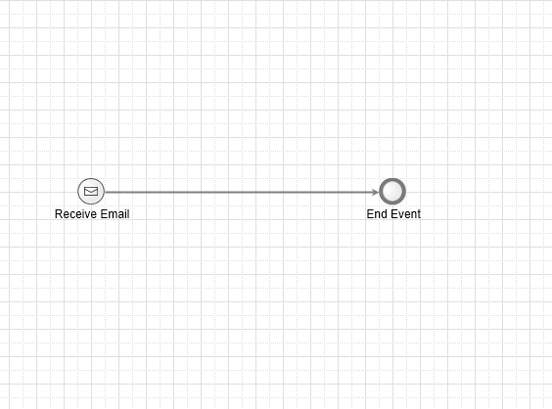
Process variables to get the email information:
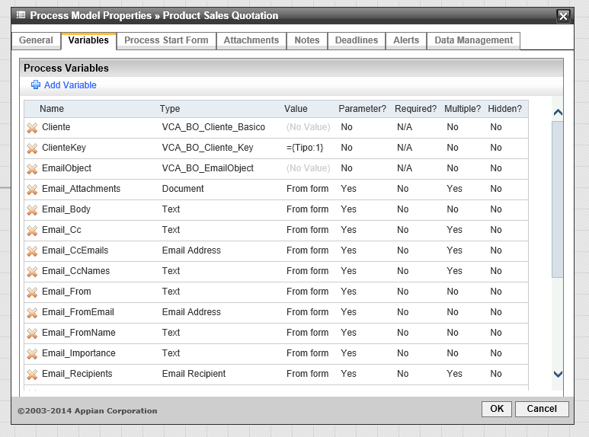

Variable mappings:
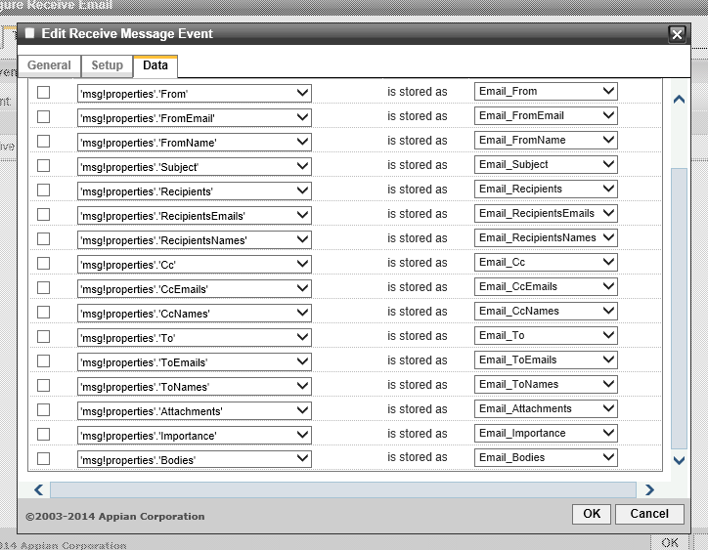

The whole email information gets stored with the exception of the body.

