Example:

Co. Code: 3345

APPIAN No. : 2498

Journal Entry: 10月服务费收入（OLON）.XLS

Supporting Documents: 转发2015年10月UCB销售预提.MSG

1. Preparer or approver got the question message to save or open attachment, seems the filename is not displayed correctly.

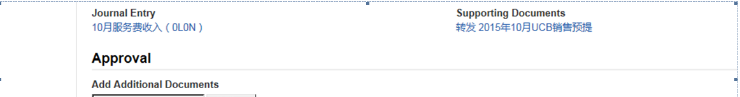



1. After clicked saved icon, system displayed below message but still couldn’t allow to open files.

cid:image001.png@01D115A7.C28A72B0

Best Regards

**Jiao Jiao Yu**

ATR-CN1433/3348/7292

MSD China Global Financial Services (GFS China)

M: + 86 571-8981 3925