**Use case:**

Search the tasks in a portal report based on the task assignees (which can be of type single or multiple and of type User or Group).

**Implementation:**

**Step-1:** Configure the Portal Report by formatting the assignees

* Add two columns in the desired Portal Task Report namely ‘Formatted user assignees’ and ‘Formatted group assignees’
* The two newly added columns should have the Formatting as Text.
* Use the PC_formatUserAssignees to format the User assignees.
* Use the PC_formatGroupAssignees to format the Group assignees.

*Configuration:*

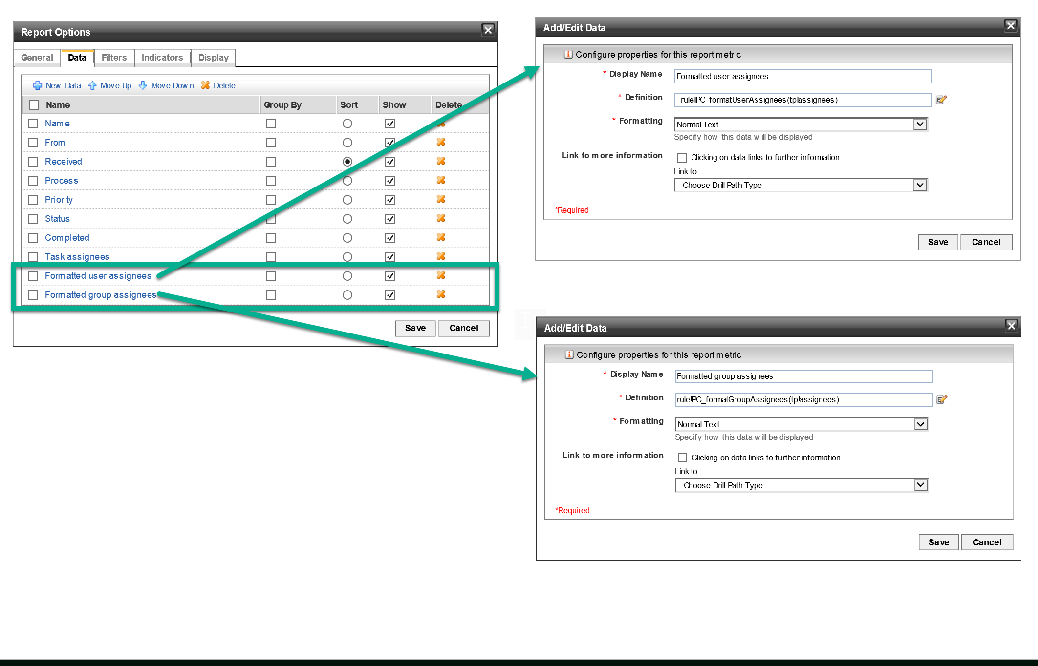

*Rules: (PC_formatUserAssignees and PC_formatGroupAssignees)*

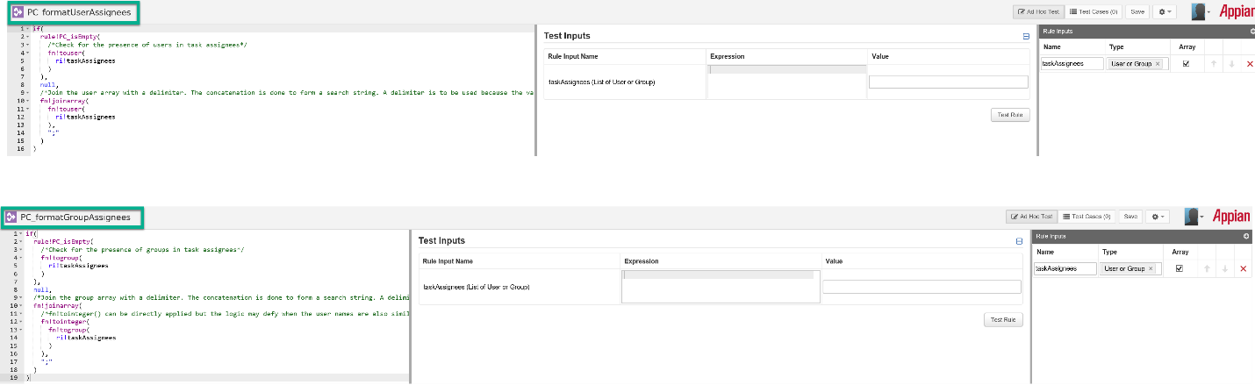

*This is how a report looks like after making above configurations:*

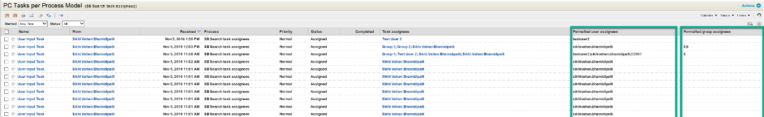

Note: There is a reason to separate task assignees and user assignees. This is to avoid the overlapping of both, that is, if the users also has numerical values as user ids, this starts giving erroneous results(when a user id and group id has same value) as we are making partial search.

**Step – 2:** Create a rule that builds the list of query filter on task assignees and the report fields.

*Rules: (*PC_createQueryFilterForTaskAssignee*)*

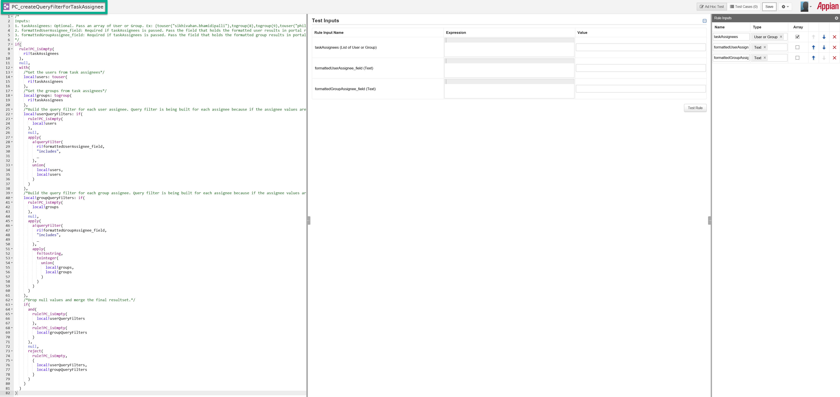

**Step – 3:** Filter the task assignees in the report by making use of the rule created in Step – 2.

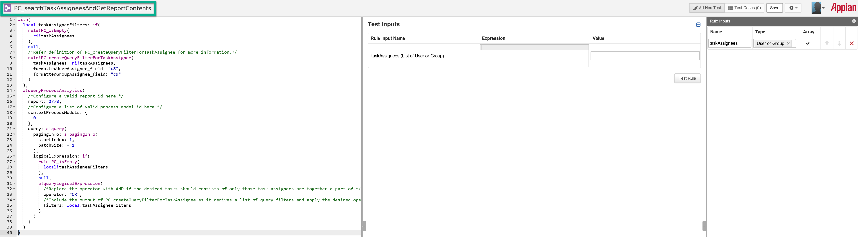

*Note: There is an application(developed on 16.3 Hotfix A) associated with the above example. Ensure that the proper testing is carried out prior to finalizing the above approach and don’t hesitate to send the feedback if any bugs are identified.*