Private KC shows it’s 0 KB

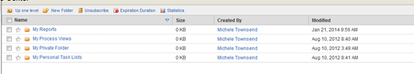

Set quota limit to 2047 from DocumentAdministration
But still it shows 1173 MB available instead of 2047 Mb. Where are remaining 874 MB.
