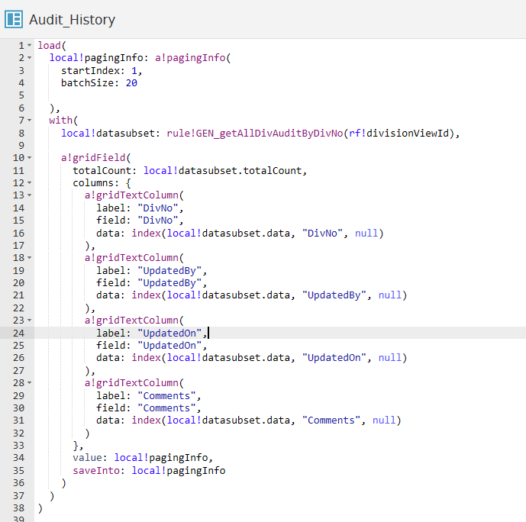

load(
local!pagingInfo: a!pagingInfo(
startIndex: 1,
batchSize: 20

),
with(
local!datasubset: rule!GEN_getAllDivAuditByDivNo(rf!divisionViewId),

a!gridField(
totalCount: local!datasubset.totalCount,
columns: {
a!gridTextColumn(
label: "DivNo",
field: "DivNo",
data: index(local!datasubset.data, "DivNo", null)
),
a!gridTextColumn(
label: "UpdatedBy",
field: "UpdatedBy",
data: index(local!datasubset.data, "UpdatedBy", null)
),
a!gridTextColumn(
label: "UpdatedOn",
field: "UpdatedOn",
data: index(local!datasubset.data, "UpdatedOn", null)
),
a!gridTextColumn(
label: "Comments",
field: "Comments",
data: index(local!datasubset.data, "Comments", null)
)
},
value: local!pagingInfo,
saveInto: local!pagingInfo
)
)
)

