Current Scenario
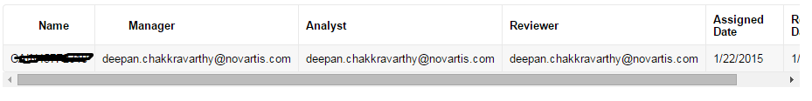
Database stored value
Rule input
Ri!user:text
=concat(user(toemailaddress(ri!user),"firstName"),user(toemailaddress(ri!user),"lastName"))
Expected output the user name
The rule output to be printed

Interface code
a!sectionLayout(
label:"Allocated Trials",
firstColumnContents:{
a!gridField(
totalCount:local!displaydatasubset.totalCount,
columns:{
a!gridTextColumn(
label:"Trial Name",
data:index(local!displaydatasubset.data,"TrialName",{})

/*links: apply(a!dynamicLink(value: _, saveInto: ri!selectedTrialID), index(local!datasubset.data,"Trial_Id",{}))*/

),
a!gridTextColumn(
label:"CAF Manager",
data:index(local!displaydatasubset.data,"CAFManager",{})
),
a!gridTextColumn(label:"Analyst",
data:index(local!displaydatasubset.data,"Analyst",{})
),

a!gridTextColumn(
label: "Reviewer",
data: index(local!displaydatasubset.data,"Reviewer",{})
),

a!gridTextColumn(
label: "Assigned Date",
data: index(local!displaydatasubset.data,"AssignedDate",{})
),

a!gridTextColumn(
label: "Release Date",
data: index(local!displaydatasubset.data,"WeekReleaseDate",{})
)
},

/*identifiers:index(local!datasubset.data,"Trial_Id" ,{}),*/
value:local!gridSelection,
saveInto:local!gridSelection
)
/* a!floatingPointField(
label: "Selected Trial ID",
value : ri!selectedTrialID,
saveInto:ri!selectedTrialID,
readOnly:true
)*/
}
)

