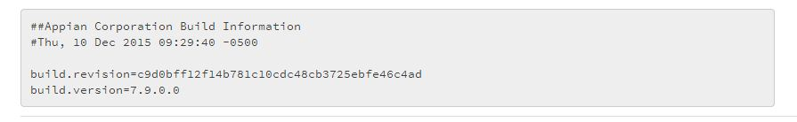

BuildInfo File Contents As Shown In Guide

Build Info after Installation:-

