Activity assignment (IE visualization on PC)
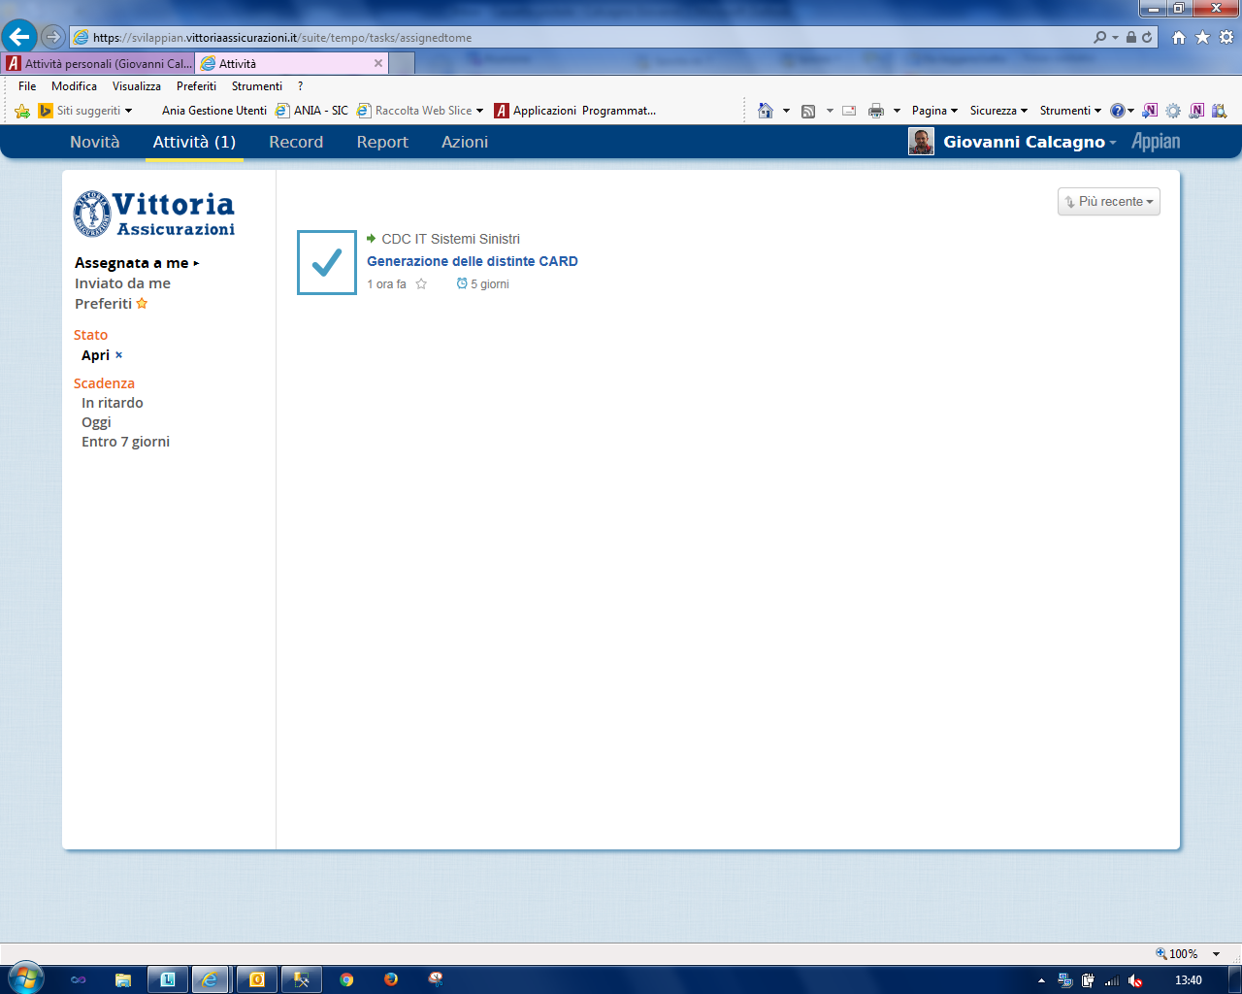
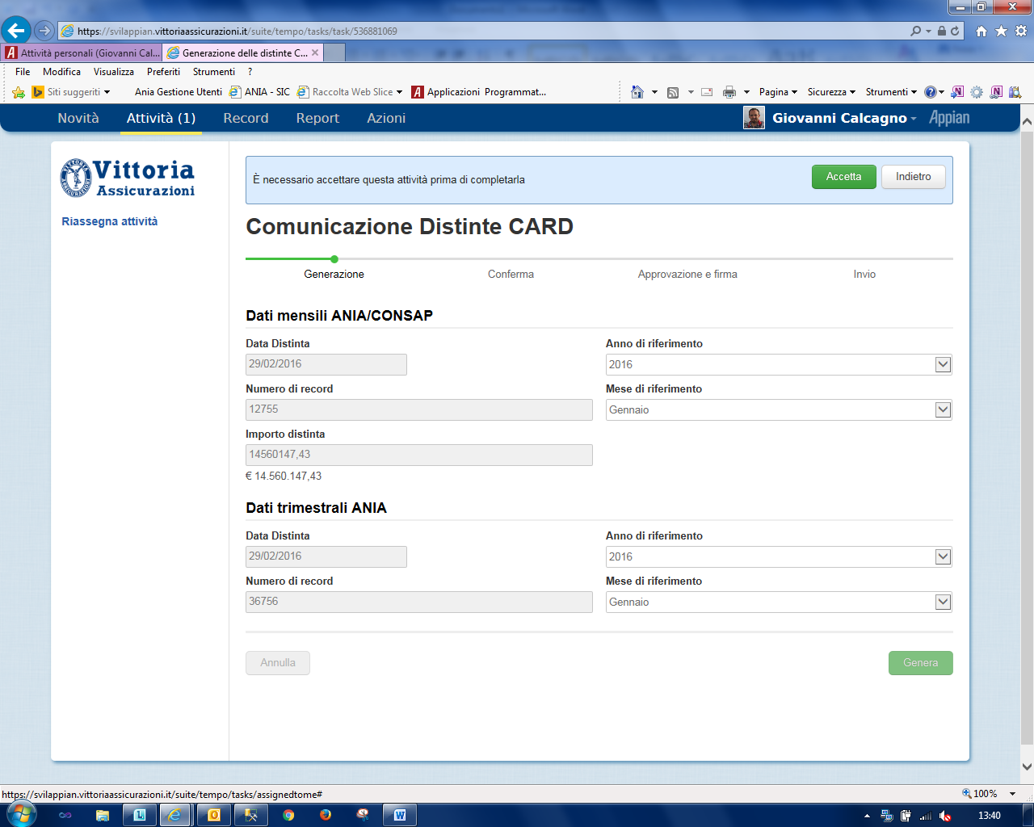
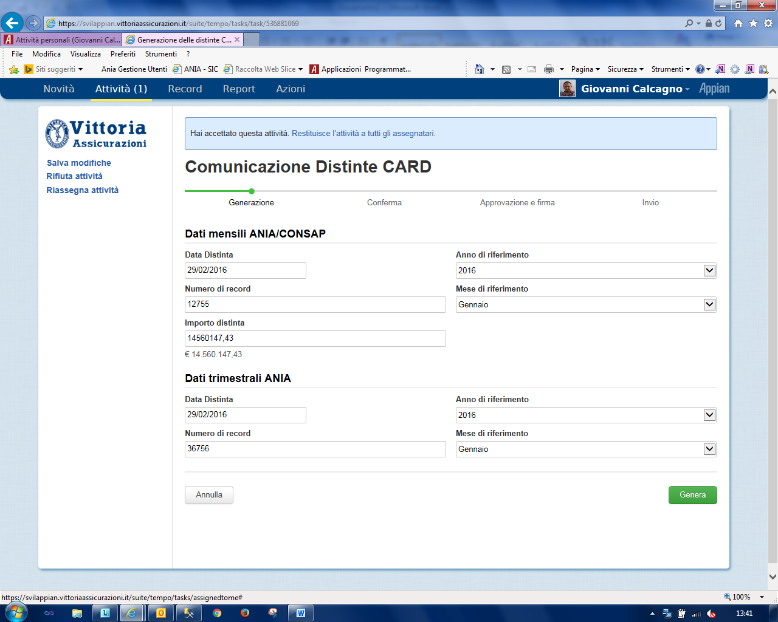

Activity assignment (Android visualization on Smartphone):
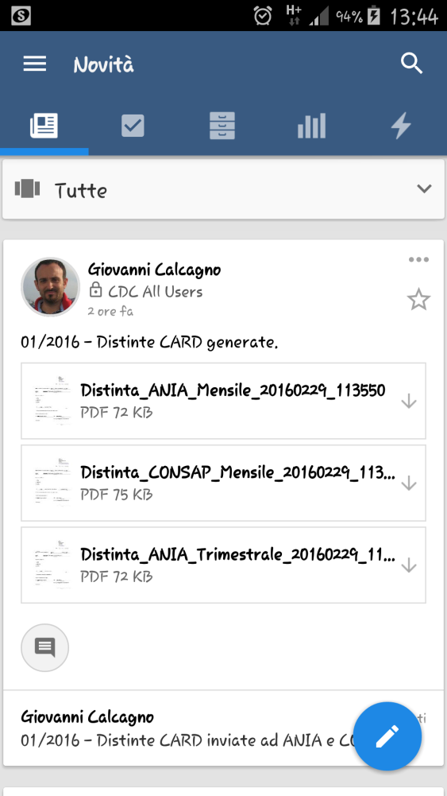
When I click on Activity, it shows the following error:

I also tried with a very simple SAIL form like this:
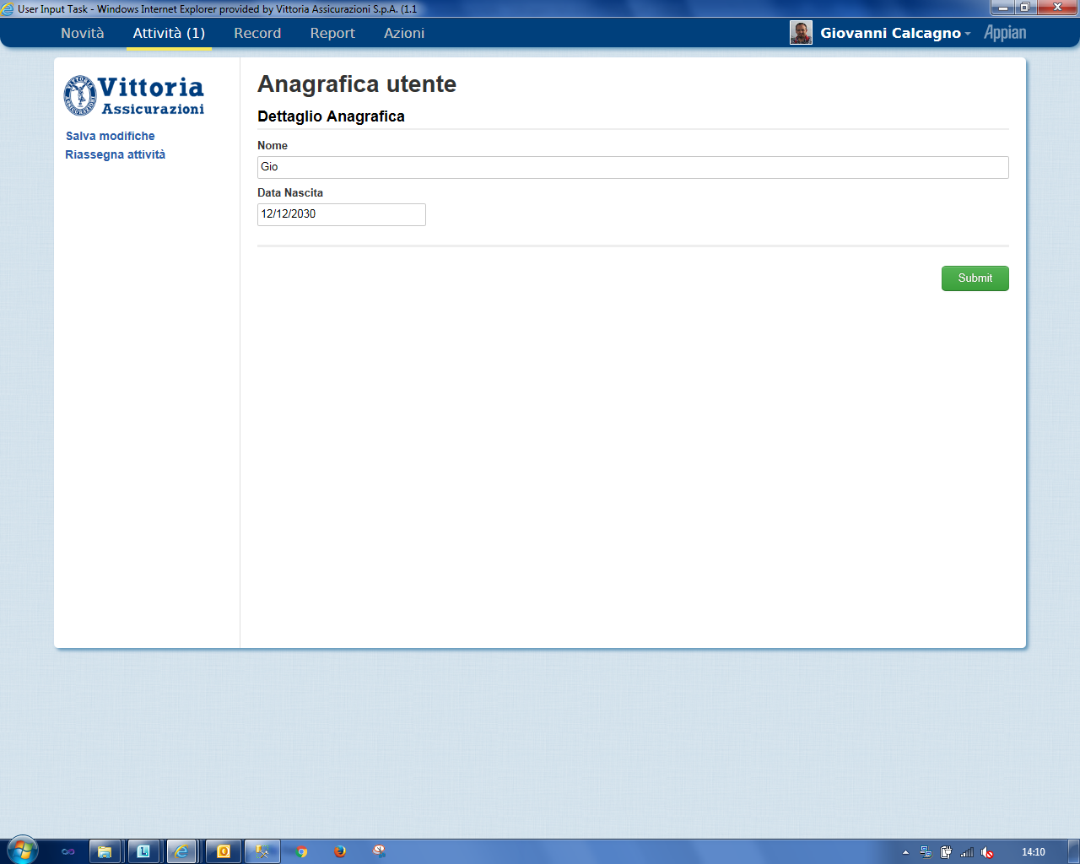

But when there’s an assigned activity, on Android we have that behavior.

