# Appian Upgrade 16.3

Changes in the User Interface

The yellow ‘Working’ sign 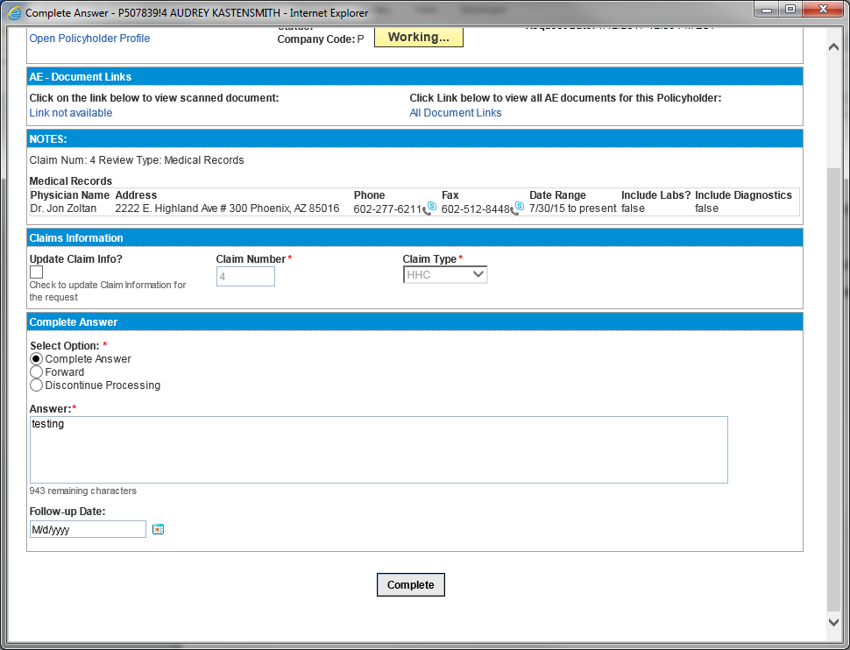when Appian is busy rendering the last action taken is no longer functioning in the portal interface.   
You will see a small ‘Working…Working…’ sign in the bottom left of your screen.

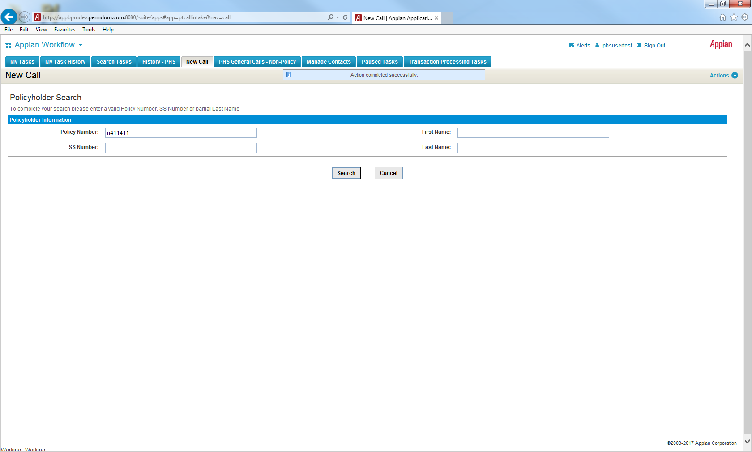



Pop-up window example: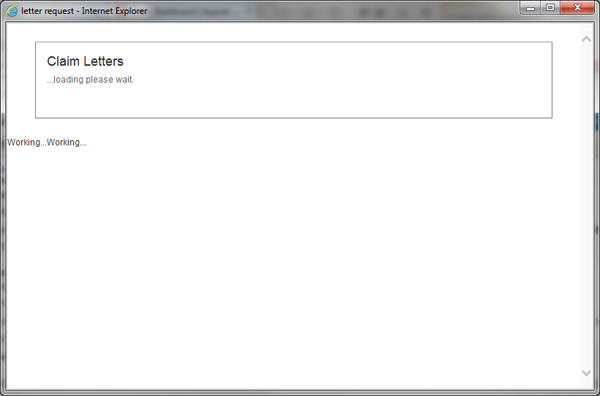

### Release notes form 16.1 which may be affecting 16.3 Portal

### Working Indicator Delay

For SAIL re-evaluations that are not triggered by a button or a link, the "Working..." indicator at the top of the screen now only appears if the re-evaluation takes longer than 500 milliseconds.