All,

It has come to our attention that users are no longer receiving notifications when incidents are entered or modified in the Safety Incident Database.

Please follow the instructions below to set up your notifications:

1. Go to the Safety Incident Database page and click the “Items” tab.

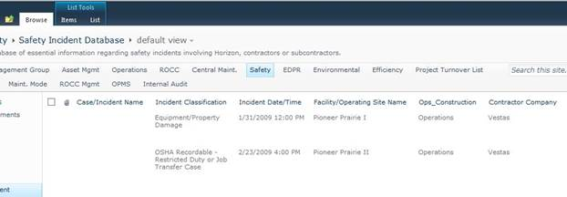

1. Under the “Items” tab, click on “Alert Me” and use the drop down menu to select “Manage My Alerts”

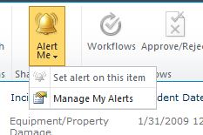

1. Click “Add Alert”

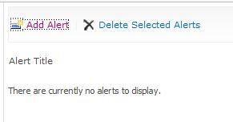

1. Choose the “Safety Incident Database” from the list on the right and click “Next”

 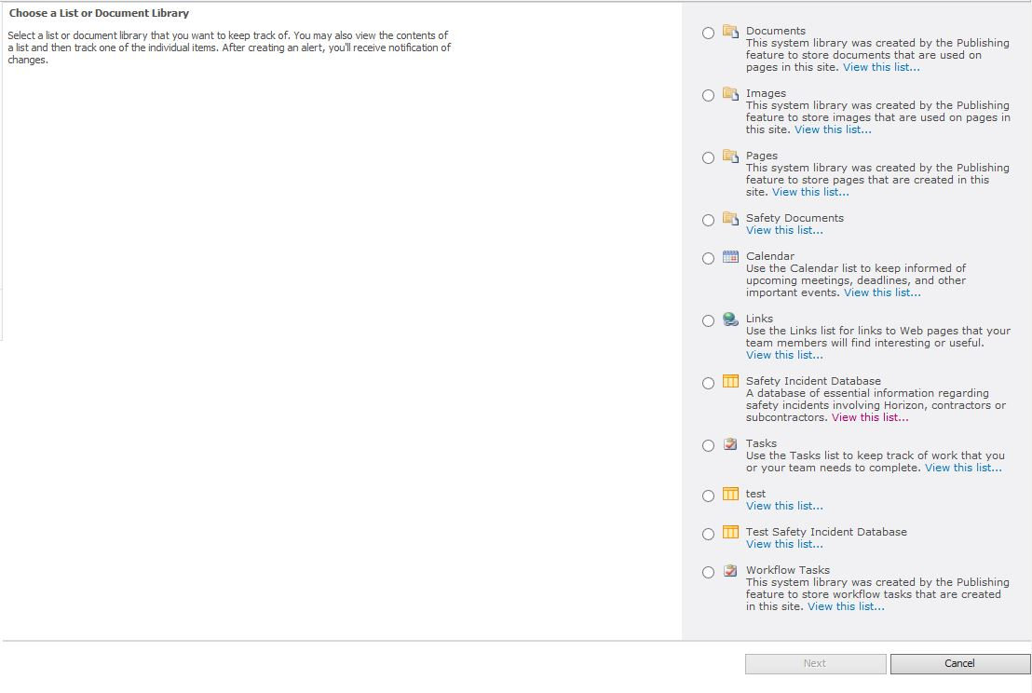

1. Set up your alerts as you choose……

