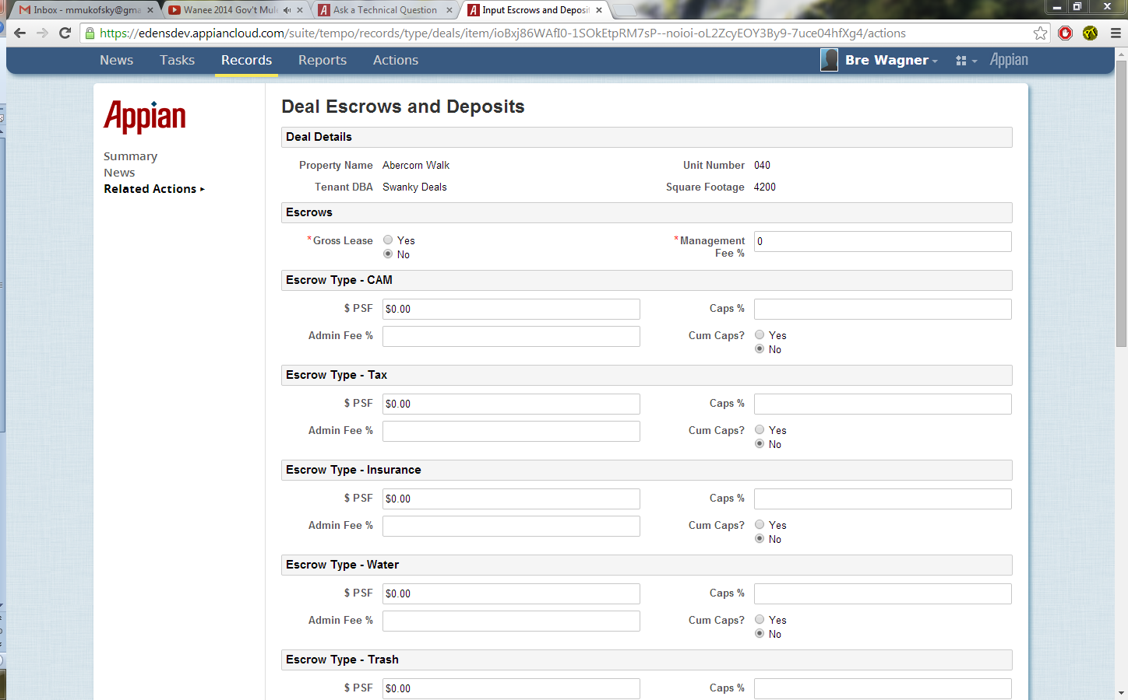
This is the top of the first form called “Deal Escrows and Deposits”
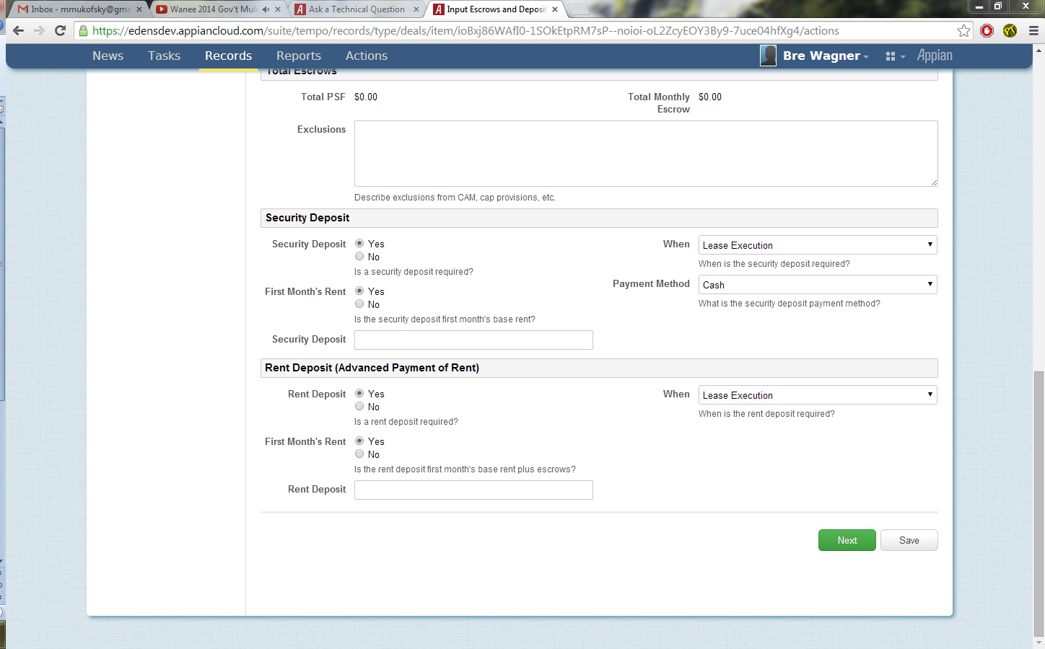
I entered the required fields and scrolled to the bottom to submit the screen, clicking “Next”.
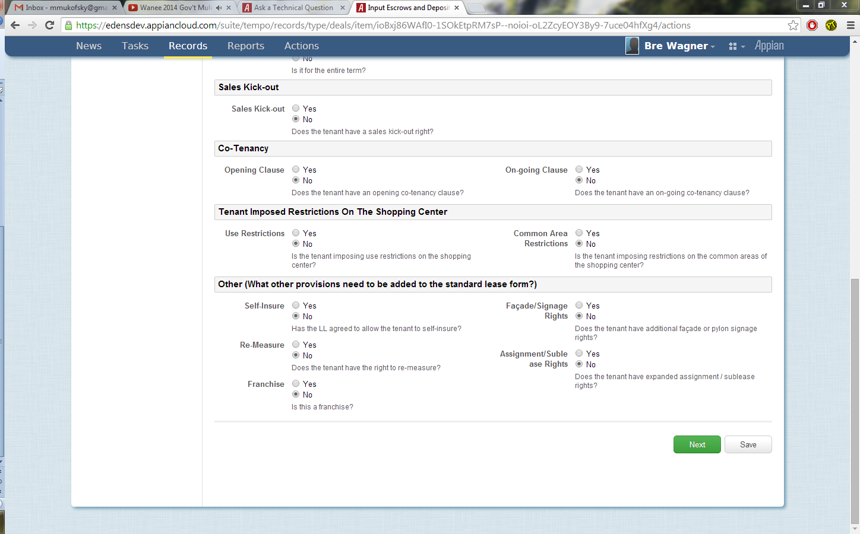
After clicking “Next” I am taken to the next form in the activity chain called “Legal Clauses”. However, the focus did not shift to the top of the screen. I am still positioned at the bottom of the new screen.
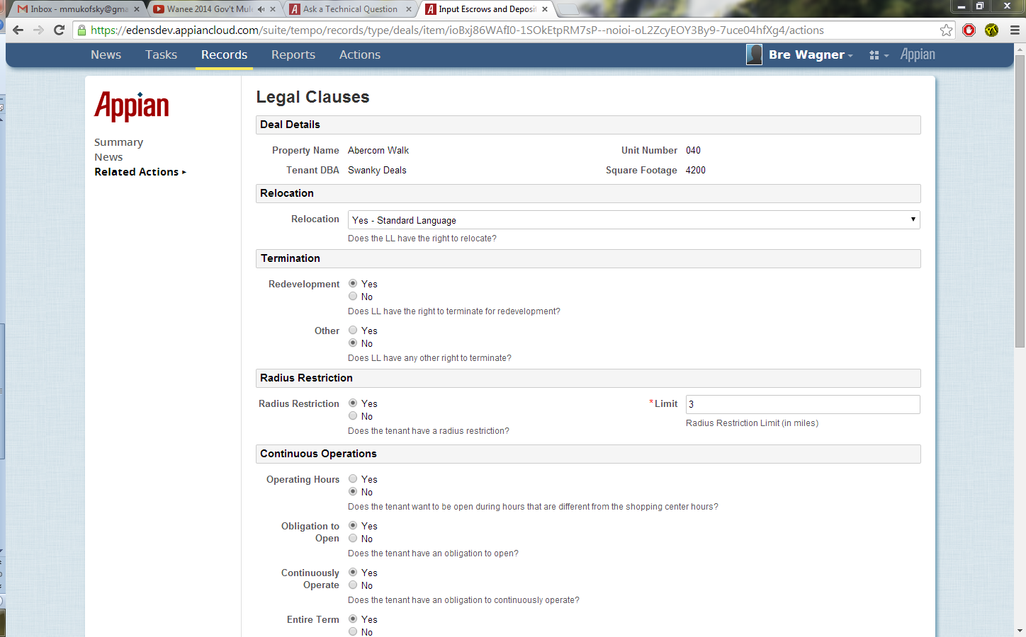
I scrolled to top of the form for demonstration purposes.

