In the dashboard by default Assest Class will be like below screenshot
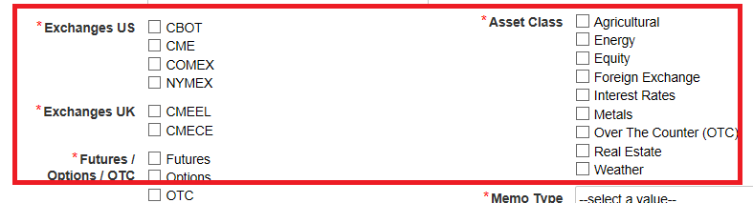
While checking individually we are getting the assest class which is in below screenshot
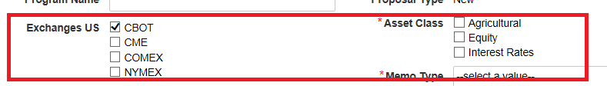

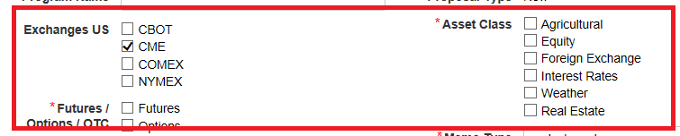
While selecting multiple (CME,CBOT) , the asset class will be ( Agricultural, Equity,Foreign Excahnge, Interest Rates, Wheather, Real Estate)

But it is capturing the default asset class which is in below screenshot
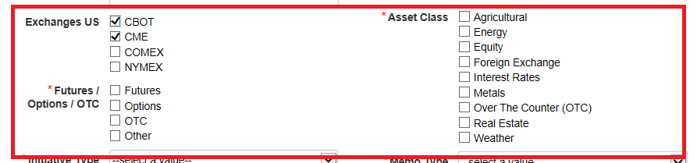
Sample code:
Individual code:

if(local!tExchange=cons!EXCHANGE_DISPLAY_LABELS_US_V2[1],
append(split(cons!ASSESTCLASS_CBOT_EXCHANGES_DISPLAY_LABELS,";")),

if(local!tExchange=cons!EXCHANGE_DISPLAY_LABELS_US_V2[2],
append(split(cons!ASSESTCLASS_CME_EXCHANGES_DISPLAY_LABELS,";")),

Combination Code:
if(and(local!tExchange=cons!EXCHANGE_DISPLAY_LABELS_US_V2[1],*/
local!tExchange=cons!TIP_EXCHANGE_DISPLAY_LABELS_US_V2[2]),
append(split(cons!TIP_ASSESTCLASS_CBOT_CME_EXCHAGES_DISPLAY,";")),

Defaulet Assest Class Code:
cons!TIP_ASSESTCLASS_DISPLAY_LABELS_V2
))))

