The following link is the starting link that’s given out followed by a screenshot of the page after going to this link.
http://mahapps.inside.ups.com/suite/apps/gbslink/gbsMainPage

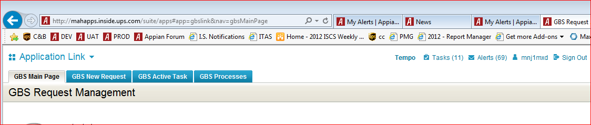

The link is translated to something else and if someone saves this as a favorite and they try to use it later in a new session, they are redirected to a different URL represented in the following screenshot:

