- Set the timer and recurring, after every 5 mins’ task will be escalated back to the orginal assigned group even if one of the group member has accepted the task
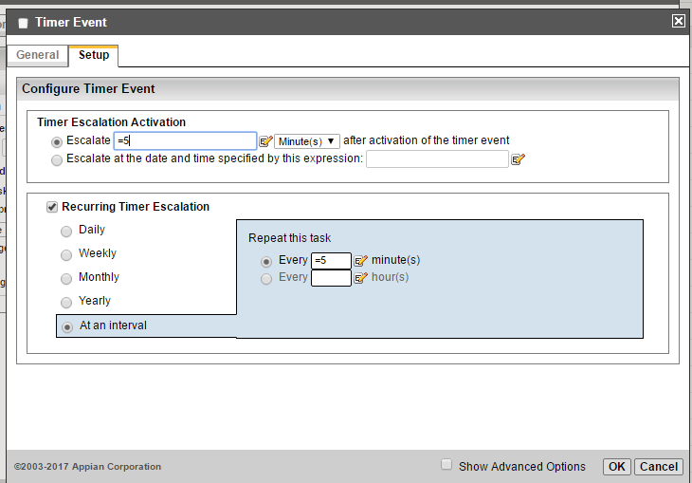

- Task is reassigned back to group on time bound escalation 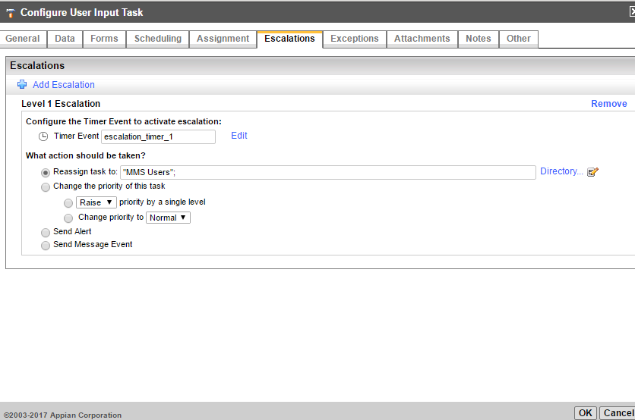
- Task is assigned to the same group as initial assignment
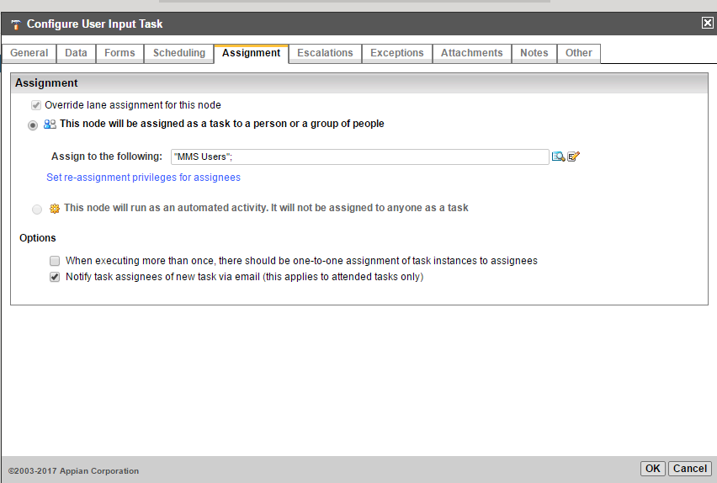

- Process is being started and one of the group member do accepts the task

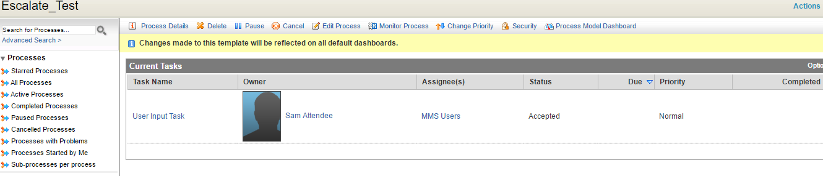

- After 5 mins, escalation will kick in and will reassign the accepted task back to the original group

