Newly created record after the upgrade and hot fix applied

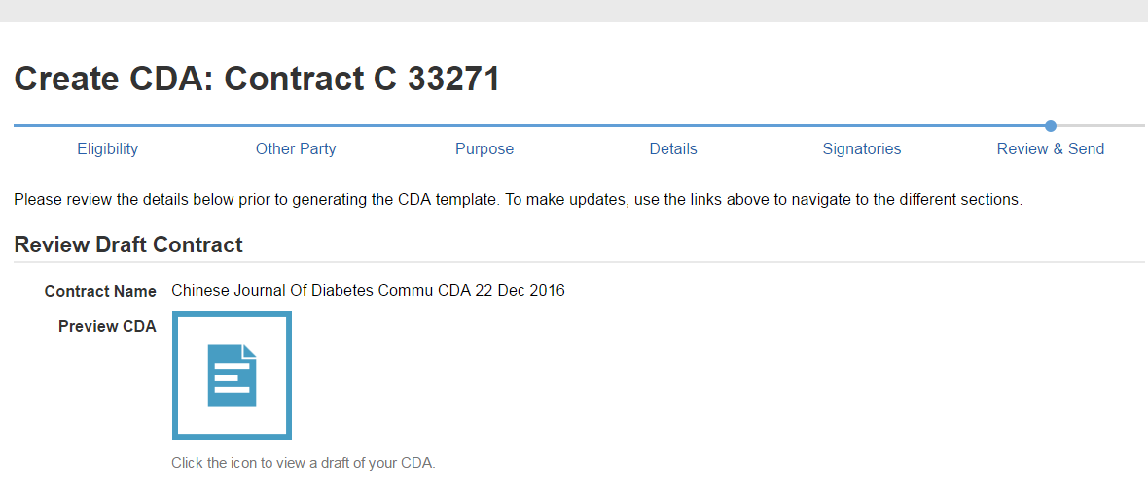
Old record created before the upgrade 16.3

