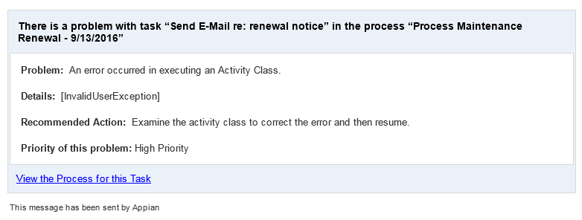

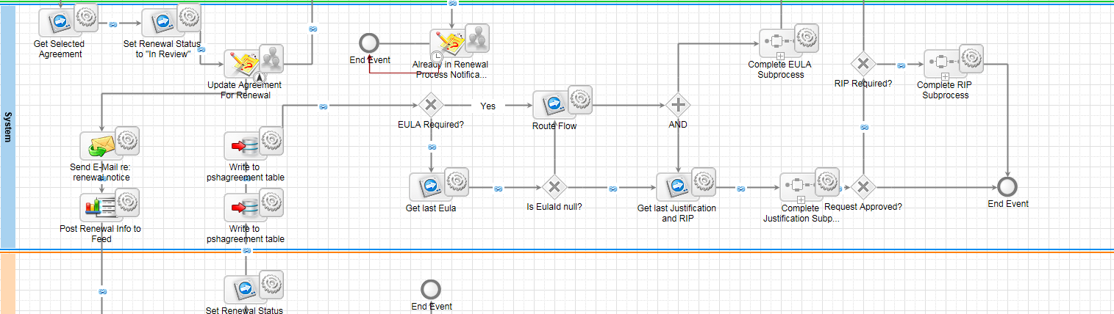

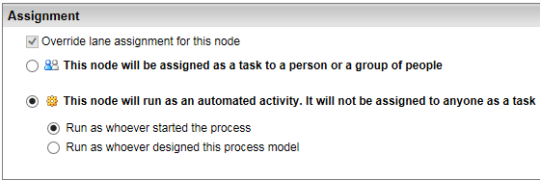

Assignment for Email, News Feed, and Subprocess nodes – should it always be ‘Run as whoever designed this process model?

