=load(
local!EMIQuery:a!queryEntity(
entity:cons!OEC_DSENTITY_TRANSACTION,
query:a!query(
aggregation:a!queryAggregation(
aggregationColumns :{
a!queryAggregationColumn(
field: "transactionAmount",
aggregationFunction: "SUM"
),
a!queryAggregationColumn(
field: "userId",
isGrouping: true
)
}
),
logicalExpression:a!queryLogicalExpression(
operator:"AND",
filters: {
a!queryFilter(
field: "transactionType",
operator: "=",
value: "EMI_INSTALL"
),
a!queryFilter(
field: "isCredited",
operator: "=",
value: false
),
a!queryFilter(
field: "isDebited",
operator: "=",
value: true
),
a!queryFilter(
field: "transactionDate",
operator: ">",
value:todatetime(now()-180)
),
a!queryFilter(
field: "transactionDate",
operator: "<",
value:todatetime(now())

),
a!queryFilter(
field: "userId",
operator: "=",
value:ri!userID
)

}
),
pagingInfo:a!pagingInfo(
startIndex:1,
batchSize:-1
)
)
),
local!EMI: todecimal(if(local!EMIQuery.totalCount=0,0.0,local!EMIQuery.data.transactionAmount)),
local!Age:30/*rule!OEC_CalculateAge(today())*/,
local!TotalTransactionCreditedQuery:a!queryEntity(
entity:cons!OEC_DSENTITY_TRANSACTION,
query:a!query(
aggregation:a!queryAggregation(
aggregationColumns:{
a!queryAggregationColumn(
field: "transactionAmount",
aggregationFunction: "SUM"
),
a!queryAggregationColumn(field: "userId", isGrouping: true)
}
),

logicalExpression: a!queryLogicalExpression(
operator:"AND",
filters: {

a!queryFilter(
field: "isCredited",
operator: "=",
value:true
),
a!queryFilter(
field: "isDebited",
operator: "=",
value: false
),
a!queryFilter(
field: "transactionDate",
operator: ">=",
value:todatetime(now()-180)
),
a!queryFilter(
field: "transactionDate",
operator: "<",
value:todatetime(now())

),
a!queryFilter(
field: "userId",
operator: "=",
value:ri!userID
)

}
),
pagingInfo:a!pagingInfo(
startIndex:1,
batchSize:-1
)
)
),
local!TotalTransactionCredited:if(local!TotalTransactionCreditedQuery.totalCount=0,0.0,local!TotalTransactionCreditedQuery.data.transactionAmount),
local!TotalTransactionDebitedQuery:a!queryEntity(
entity:cons!OEC_DSENTITY_TRANSACTION,
query:a!query(
aggregation:a!queryAggregation(
aggregationColumns:{
a!queryAggregationColumn(
field: "transactionAmount",
aggregationFunction: "SUM"
),
a!queryAggregationColumn(field: "userId", isGrouping: true)
}
),

logicalExpression: a!queryLogicalExpression(
operator:"AND",
filters: {

a!queryFilter(
field: "isCredited",
operator: "=",
value:false
),
a!queryFilter(
field: "isDebited",
operator: "=",
value: true
),
a!queryFilter(
field: "transactionDate",
operator: ">=",
value:todatetime(now()-180)
),
a!queryFilter(
field: "transactionDate",
operator: "<",
value:todatetime(now())

),
a!queryFilter(
field: "userId",
operator: "=",
value:ri!userID
)

}
),
pagingInfo:a!pagingInfo(
startIndex:1,
batchSize:-1
)
)
),
local!TotalTransactionDebited:if(local!TotalTransactionDebitedQuery.totalCount=0,0.0,local!TotalTransactionDebitedQuery.data.transactionAmount),
local!TotalAvailableBalance:todecimal(local!TotalTransactionCredited)-todecimal(local!TotalTransactionDebited),
local!SalaryQuery:a!queryEntity(
entity:cons!OEC_DSENTITY_TRANSACTION,
query:a!query(
aggregation:a!queryAggregation(
aggregationColumns :{
a!queryAggregationColumn(
field: "transactionAmount",
aggregationFunction: "AVG"
),
a!queryAggregationColumn(
field: "userId",
isGrouping: true
)
}
),
logicalExpression:a!queryLogicalExpression(
operator:"AND",
filters: {
a!queryFilter(
field: "transactionType",
operator: "=",
value: "SALARYCREDITED"
),
a!queryFilter(
field: "isCredited",
operator: "=",
value: true
),
a!queryFilter(
field: "isDebited",
operator: "=",
value: false
),
a!queryFilter(
field: "transactionDate",
operator: ">",
value:todatetime(now()-180)
),
a!queryFilter(
field: "transactionDate",
operator: "<",
value:todatetime(now())

),
a!queryFilter(
field: "userId",
operator: "=",
value:ri!userID
)

}
),
pagingInfo:a!pagingInfo(
startIndex:1,
batchSize:-1
)
)
),
local!AvgSalary:todecimal(if(local!SalaryQuery.totalCount=0,0.0,local!SalaryQuery.data.transactionAmount)),
local!dataSet:{
AverageSalary:todecimal(local!AvgSalary),
TotalAvailableBalance:todecimal(local!TotalAvailableBalance),
lastMonthEMI:todecimal(local!EMI),
Age:tointeger(local!Age)},
local!dataSubset:todatasubset(local!dataSet,topaginginfo(1,-1)),

local!dataSubset
)
From Live view of expression rule in value field we give 3, the output is given as expected datasubset.
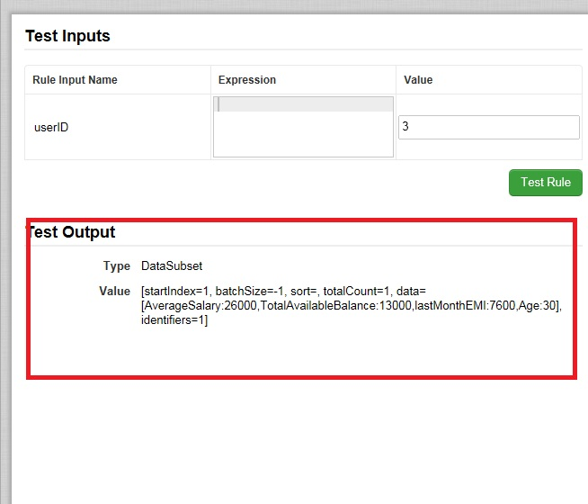

Now this is mapped to process variable (TransactionalData type datasubset)in output of script task as shown below:
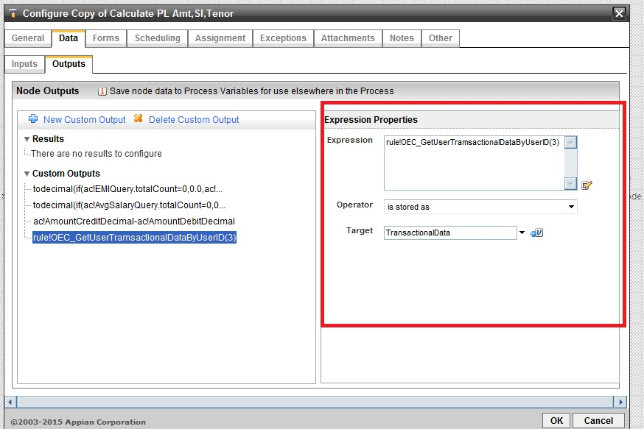

In Runtime we get :
