Send Message Event (changing this from CDT to pv does not affect the outcome):
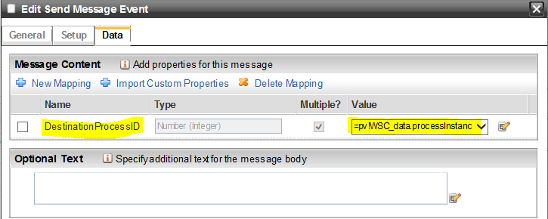
Alert configured for sender:
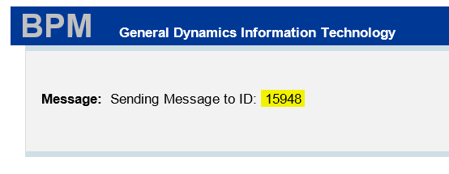
Alerts configured for receiver, ALL WAITING ARE RELEASED!
This is correct:
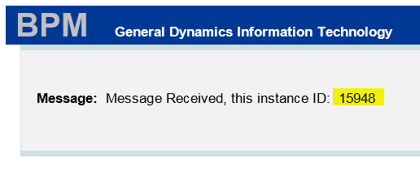
This is NOT CORRECT! Process should not be released:
