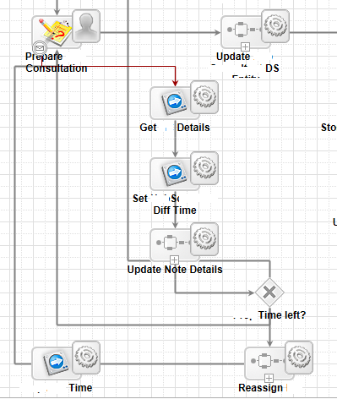

This is where user enters notes and exception occurs as well. If user already entered notes upon exception the notes should be saved and rest of flow should occur.