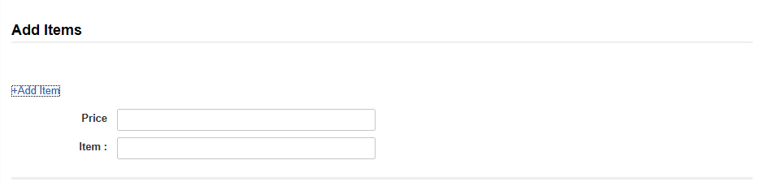

=load(
local!items: {""},
local!addItem,
local!price,
a!formLayout
(
firstColumnContents:
{
a!sectionLayout(
label: "Add Items ",
firstColumnContents:
{
a!textField(
label:"",
labelPosition:"ADJACENT",
readOnly:true
),
a!linkField(
label: "",
links: {
a!dynamicLink(
label: "+Add Item",
value: "add",
saveInto: local!addItem
)
}
)
},
secondColumnContents:
{}
),
with(
if(isnull(local!addItem),{},
a!sectionLayout
(
firstColumnContents:
{
a!textField(
label:"Price",
labelPosition:"ADJACENT",
value:local!price,
saveInto:local!price
),
a!applyComponents
(
function: rule!ucDynamicField_Each(index: _, items: local!items),
array: 1+enumerate(count(local!items))
)
},
secondColumnContents:
{
a!textField(
label:"",
labelPosition:"ADJACENT",
readOnly:true
)

}
)
))

},
buttons: a!buttonLayout(
primaryButtons: a!buttonWidgetSubmit(
label: "Submit"
)
)
)

