Results
Test #1: =if(isnull(pv!auth_usernames),touser("Administrator"), pv!auth_usernames)
Username format
Result: New rows are not showing at all but old rows are showing correctly

TEST #2: =if(isnull(pv!auth_usernames),null, pv!auth_usernames)
Username format
Result: Same as TEST #1
TEST #3: =typename(typeof(pv!auth_usernames))
Normal Text format
Result: new ones are showing any type but old are List of Text String
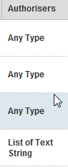
TEST #4: =touser(pv!auth_usernames)
Normal Text format
Result: Of the new ones only the first name is showing the old ones are treated like a list
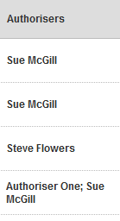
TEST #4b: =touser(pv!auth_usernames)
Username format
Result: same as TEST #4a

