This is the report using the Username format on the Authorisers column (which is the display format I want):
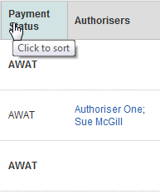
It is formatted as:
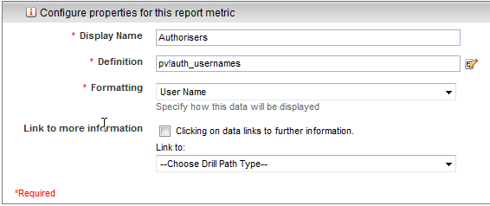
If I switch to the User or Group Name format I get this:
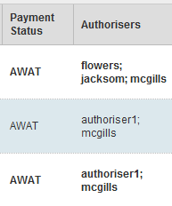

The data for the 1st cases is as follows:
auth_usernames | Text | Yes | flowers; jacksom; mcgills
And the 2nd case:
auth_usernames | Text | Yes | authoriser1; mcgills

