I have create the tempo report from the already existing Portal Report using the queryProcessor.
As an admin when I access the report in the Reports Tab of the Tempo I am able be see all the component like Pie Chart and on the click of the Pie chart I am able to access the data as well.
Please see the below screen shot for better understanding .

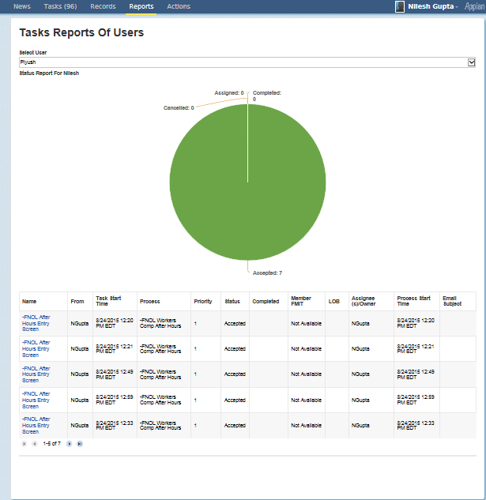

Challenge I am Facing:
But when I login as the manager which is the basic user I am unable to access the data and The Pie charts
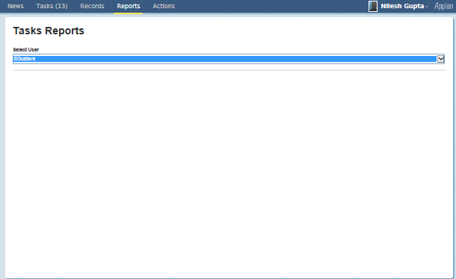

The configuration which I did for making it available to manager is also not working,
Please see the below screenshot for the role map configuration.
Process Model Security: I have added a new Group called Report Viewers and given the configuration as Manager:

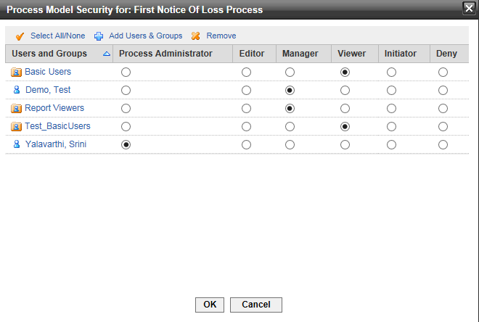

Similarly I have also configured the Process Security as well which is inherited from the Process Model Security.

