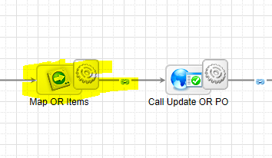

Source Field, it is defined as text & this CDT was created in Appian.
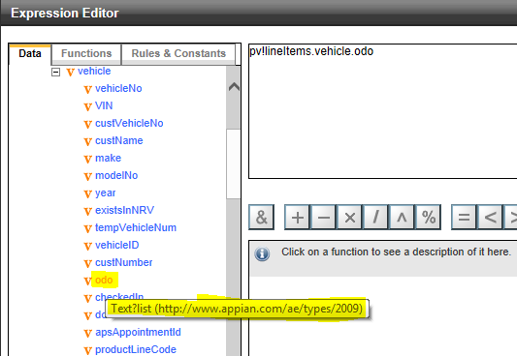

Target Field (This CDT was created from Service exposed by external party and data type was defined as xsd:decimal) As per XML definition decimal cannot accept value in exponential notation.
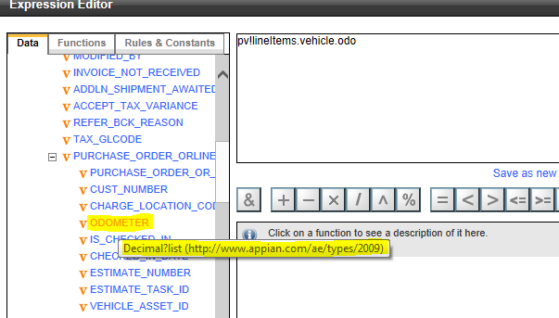

This is the mapping. We are mapping Tax to Decimal. Automatically, Appian converts into exponential notation as target field is of type Decimal. Irrespective of whether, schema data type is defined as decimal, double or float. Appian always treat it like Decimal and it stores in exponential format if value is greater than 9999999
