Locator change Issue Description:
For Colo Portal automation we use ID/Xpath as Locator of the web element(textbox,dropdown box etc.,) and that is extracted from HTML code of the web page. Eg. Locator of the drop down or web table can be represented as “Id= asi_grid_analytics_45_portlet_139” or x-path can be represented as “Xpath=//*[@id='asi_gridMain2_analytics_22320_portlet_139']/div[2]/label[3]/span[2]/select”.

Actual behavior
In each sprint the ID and X-path are getting changed, e.g.
• Id= asi_grid_analytics_5465_portlet_78978 or Id= asigrid_analytics_5465_portlet_78978
• Xpath=//*[@id='asi_gridMain2_analytics_22320_portlet_139']/div[2]/label[5]/span[3]/select

The above change is not for all the web elements across the application, but it gets affected randomly to some of the web element. The impact is automation script are failing and fixing them consumes time. Whenever there is release we end up fixing the automation scripts instead of executing the scripts. This issue occurs constantly in all the sprints wherein finding out the locator change and fixing consumes lots of time.

Expected behavior
The ID/Xpath should be same across all the scripts after updates to process and enhancements. This value should not get changed, in this case the automation scripts will not fail.

Steps to find the locators change.

1. Locator of the web element is represented in Id which can be found in the HTML code of the web page. Eg. Locator of the drop down or web table can be represented as “Id= asi_grid_analytics_45_portlet_139” in HTML code.
2. The above locator can get changed in each release as something like this “Id= asi_grid_analytics_5465_portlet_78978” or “Id= asigrid_analytics_5465_portlet_78978”

Because of the above changes the scripts are failing since we use the same locators in the test scripts to identify the web elements.

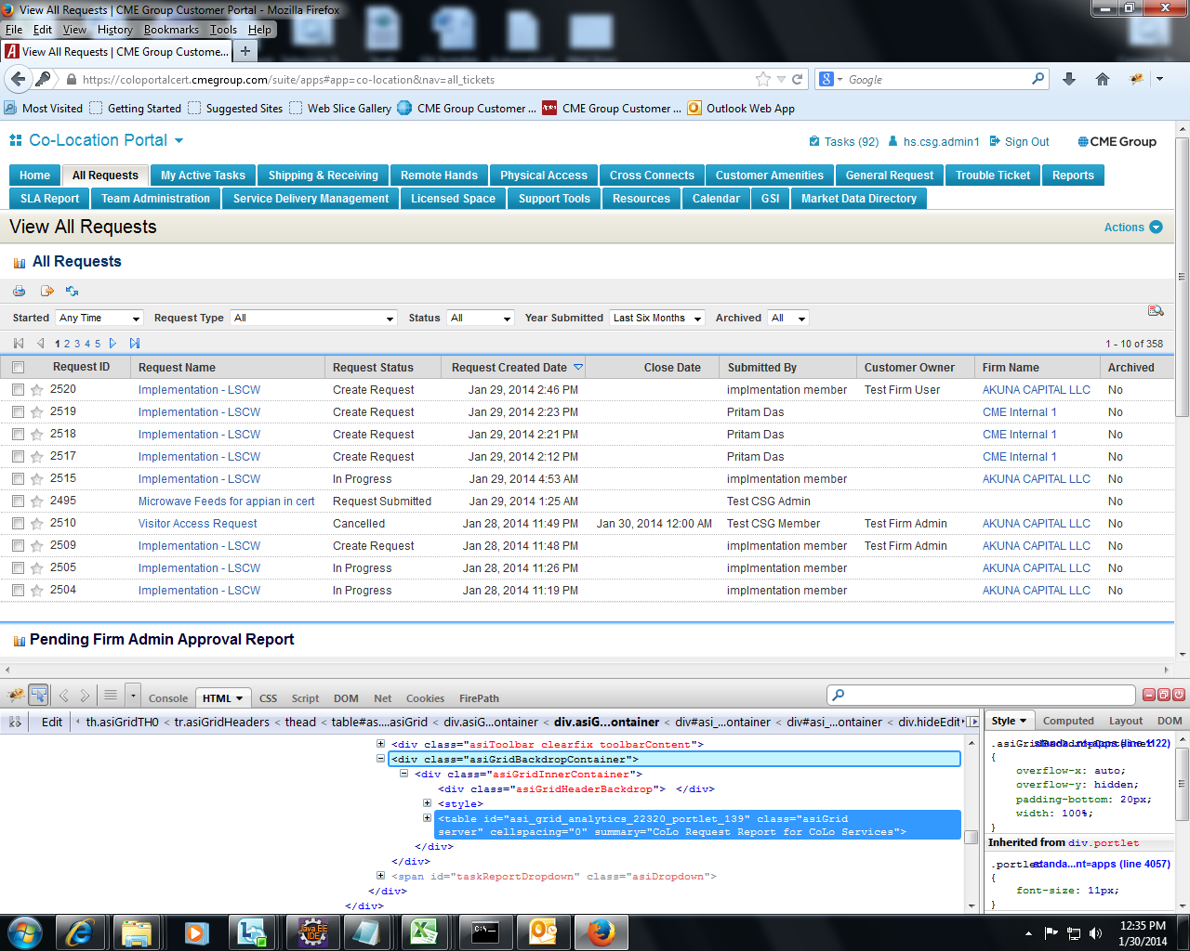

The actual ID for above table is “Id= asi_grid_analytics_22320_portlet_139”. So when there is a change in locator it will change it as “Id= asi_grid_analytics_546_portlet139” or “Id= asigrid_analytics_876_portlet_139”
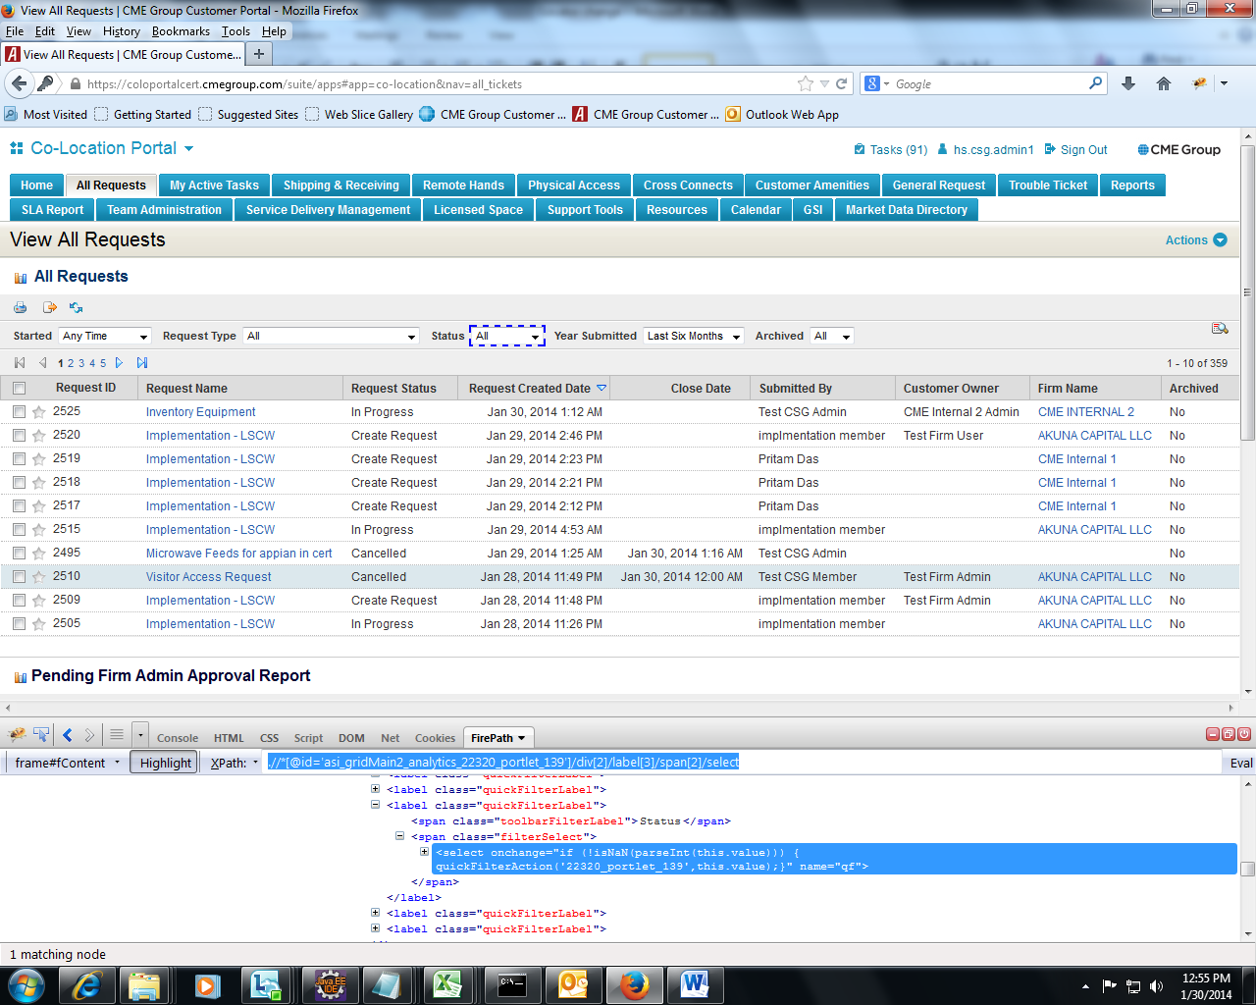
The actual xpath of the above status drop down list is
“Xpath=//*[@id='asi_gridMain2_analytics_22320_portlet_139']/div[2]/label[3]/span[2]/select”

With each build this might change to something like this.
“Xpath=//*[@id='asi_gridMain5_analytics_223_portlet_139']/div[2]/label[4]/span[3]/select”

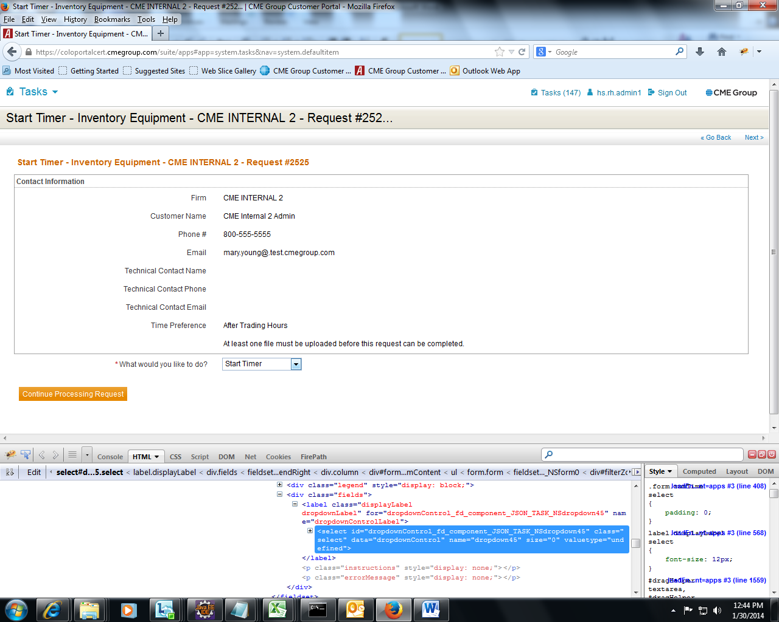

The actual id for the above drop down list is “Id=dropdownControl_fd_component_JSON_TASK_NSdropdown45”. This can get change to “id=dropdownControl_fd_component_JSON_TASK_NSdropdown76”.

Generally locators change occurs the application randomly for the various web elements. For some locators it doesn’t change.

