Add Documents to ZIP
Step 1: go to data -> Inputs and select the document which you have as a template in Base Document
For example: If have ‘abc.doc’ template and in that I want to replace on image then I choose ‘abc.doc’ as base document.
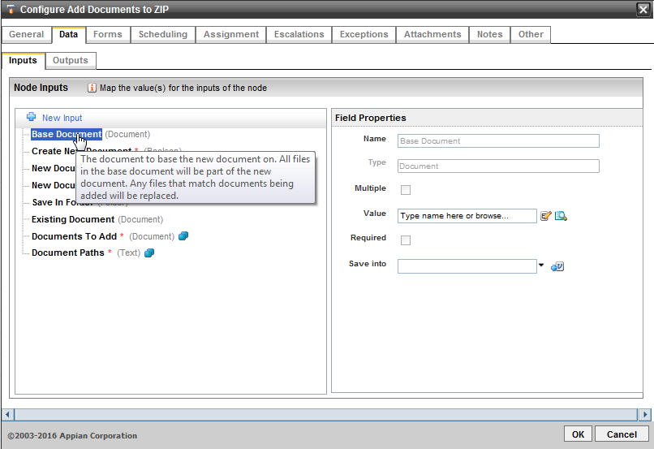
Step 2: Select ‘Create New Document’ and set true / false based on the requirement. If you want to create new document the select true or else if you want to override the existing then select false.
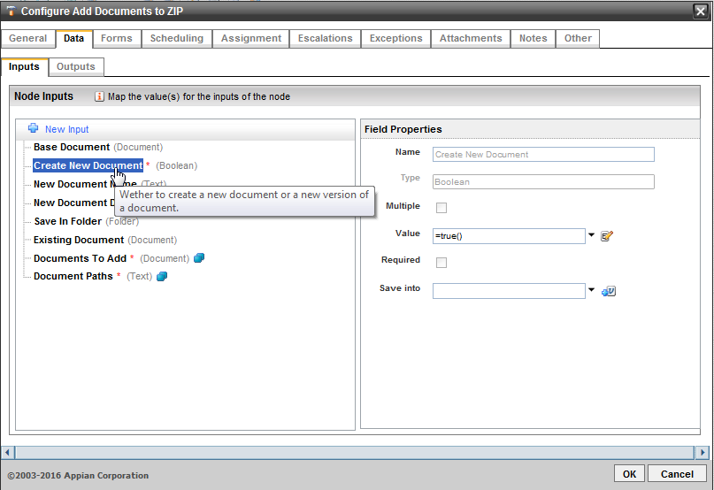
Step 3: If you select Create New Document as true and if you want to give a new name to the document which is going to be generated then give that name in ‘New Document Name’

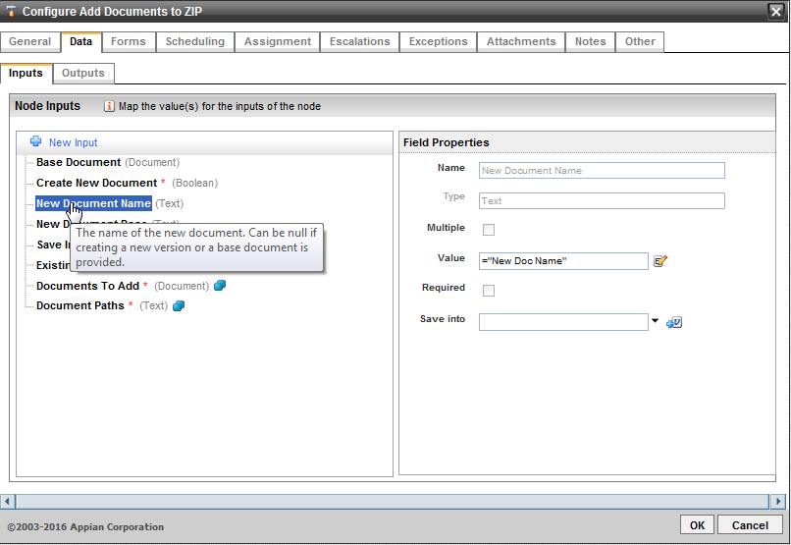
Step 4: I you want to give any description to the newly created document then give that in ‘New Document Desc’

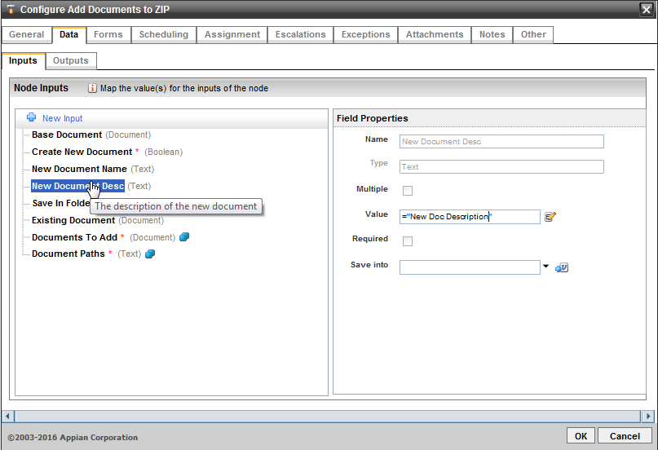

Step 5: Select Save In Folder and select the folder where you want to save the new documents

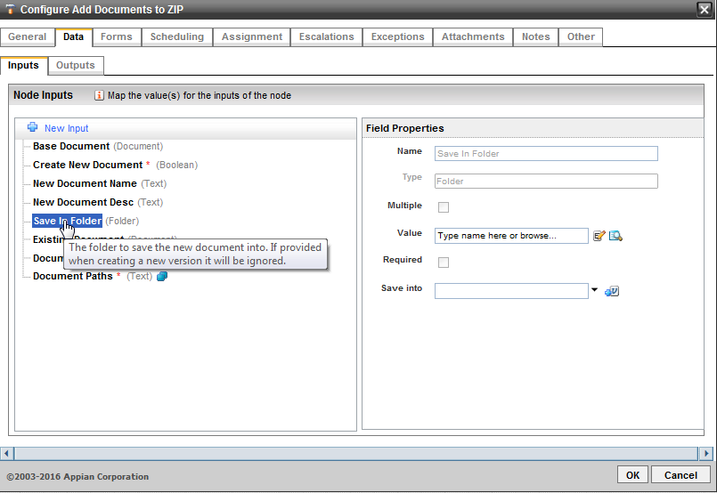
Step 6: I you don’t want to create the new document and overriding the existing one then select that existing document so that it will create new version for it.

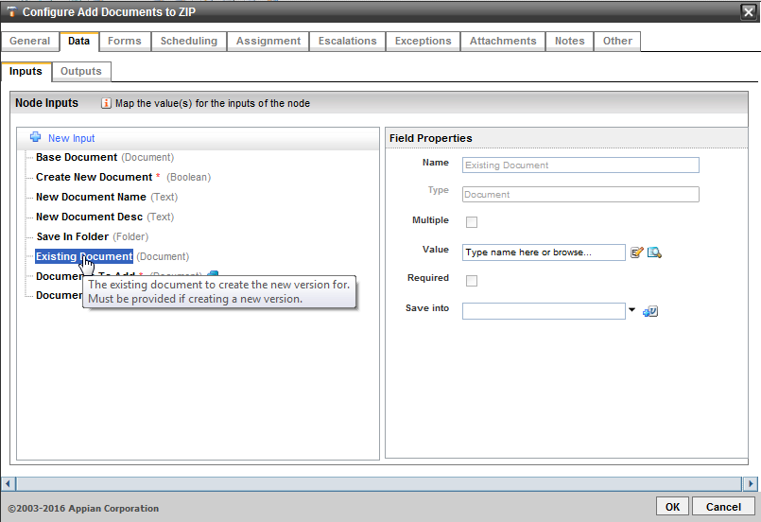
Step 7: Select the image you want to add to the document in ‘Document to Add’
For example: Image3.jpg
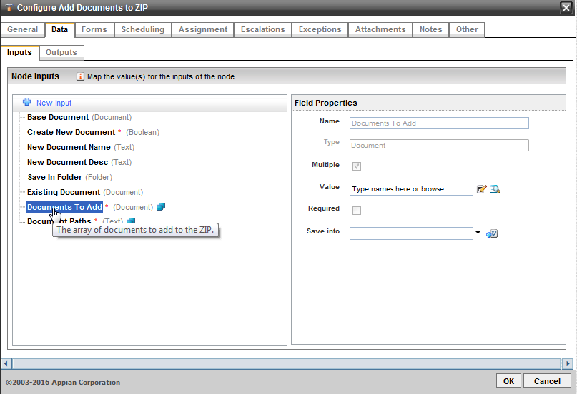
Step 8: Select the path of the old mage which you want to override with new one.
For example: I have image1.jpg in my doc and I want to replace it with new image then I will choose that like ‘/word/media/image1.jpg’
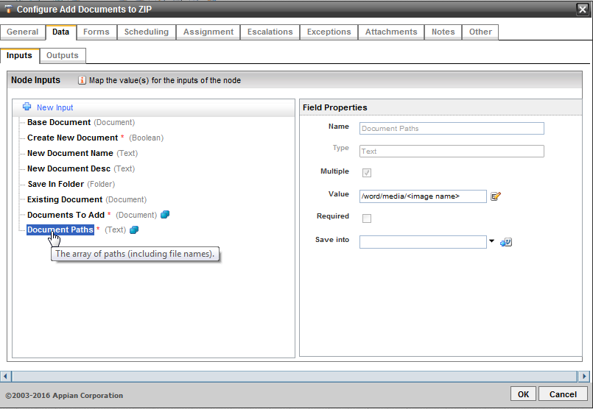
Step 9: Go to Outputs tab and select the ‘New Document Created’, Provide the process variable of type document to save the newly created / Updated document for later use in the process.
