PDF Screen shot # [Generated PDF]
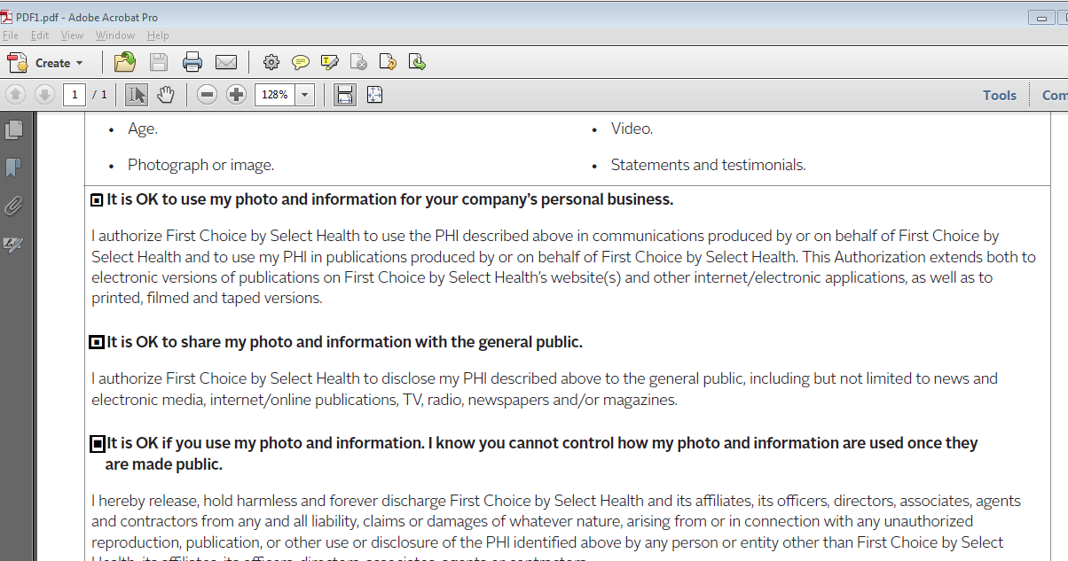

Appian Form #
Same PDF getting displayed in Appian Form then without Check Box.
