- We have a task to perform and we want to edit the time spent.
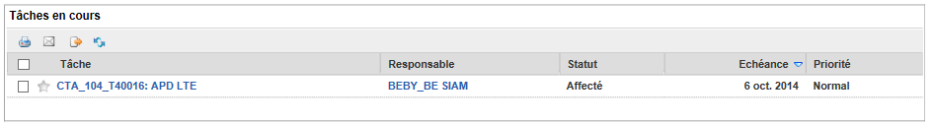
- We fill “temps passé” and press “pointage partiel”
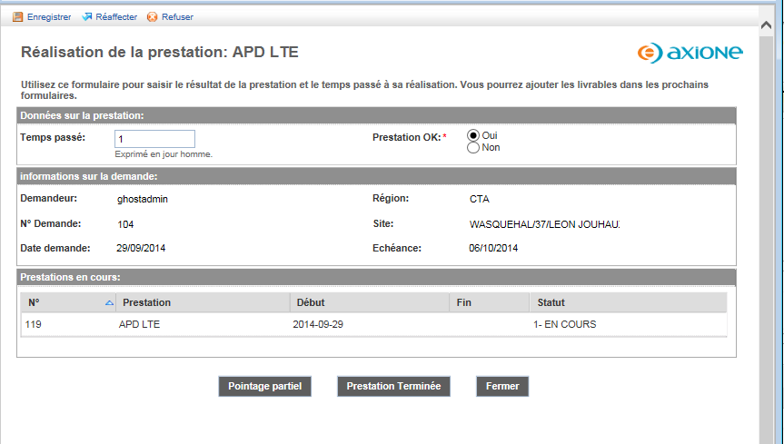
- We have a loop going back to the original task as we just wanted to save the « temps passé » (time spent) in the database

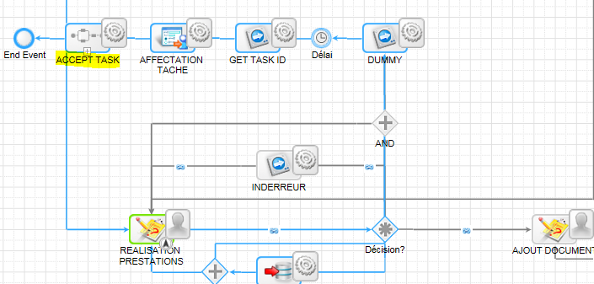
- Unfortunately although the smart service has run correctly, the new task status has not been updated to Accept as illustrated below.
