I created a new Third-Party Credential (FTP_DEV) and set the value of the credentials ‘Username’ and ‘Password’ to what we previously had stored in constants and used in the previous version of this plugin. (*Note that I tested the connection and the result was successful)*

I created a new constant (ESC_FTP_KEY) with the value = ‘FTP_DEV’ and set the value of the data input, External System Key to this constant.

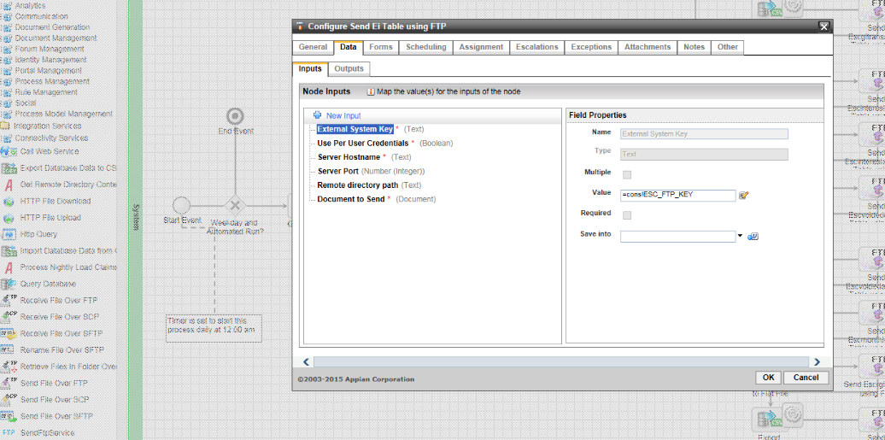The Updated SFTP plugin:

Use Per User Credentials (= False)

Remaining inputs are set to the same value (constants) used in the previous version of the plugin

Data inputs for the previous version included:

* Document (Document)
* Password (Text)
* Port (Number[Int])
* Remote Dir Path (Text)
* Server Host (Text)
* Username (Text)