Not Able To Take Certification

I was trying to give ACAD Level 1 certification and Certification was assigned in my task list. Once I tried to open the task and start the certification by clicking Begin now but task suddenly disappeared and was not able to see the task again. Even I tried from different system.
So I was not able to take Certification. Need help .Following are screen shots of what I did.

In Actions-> Certifications ->
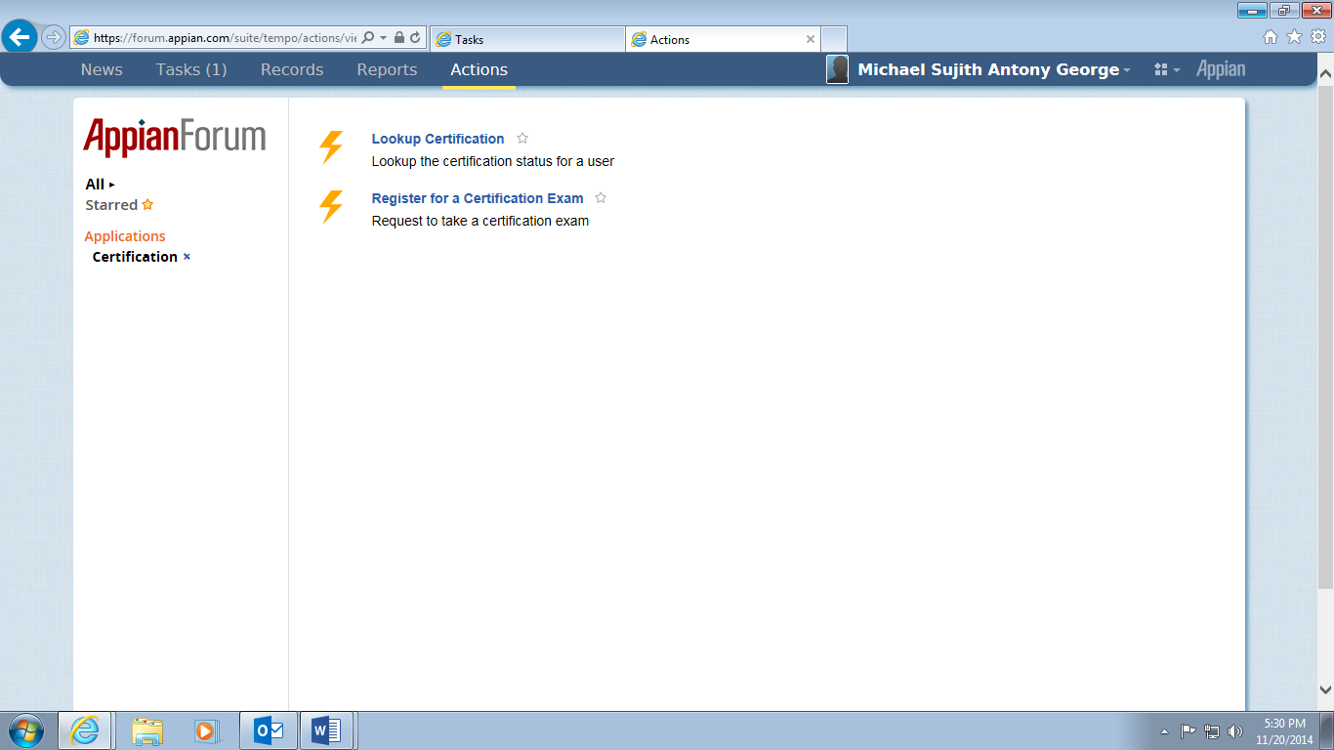

Register for Certification
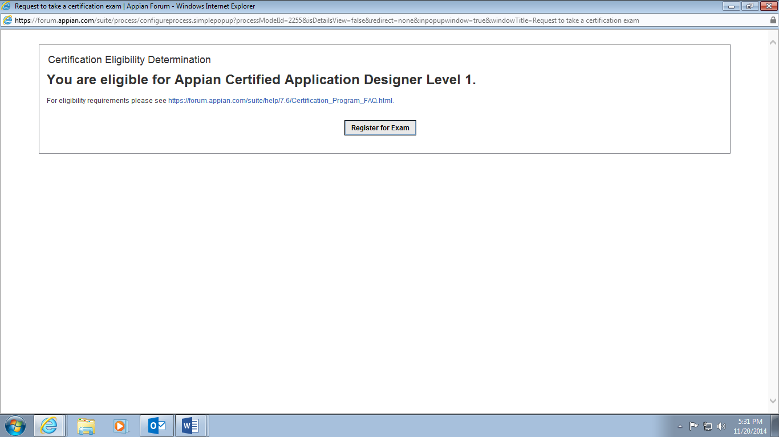

Registered for Exam

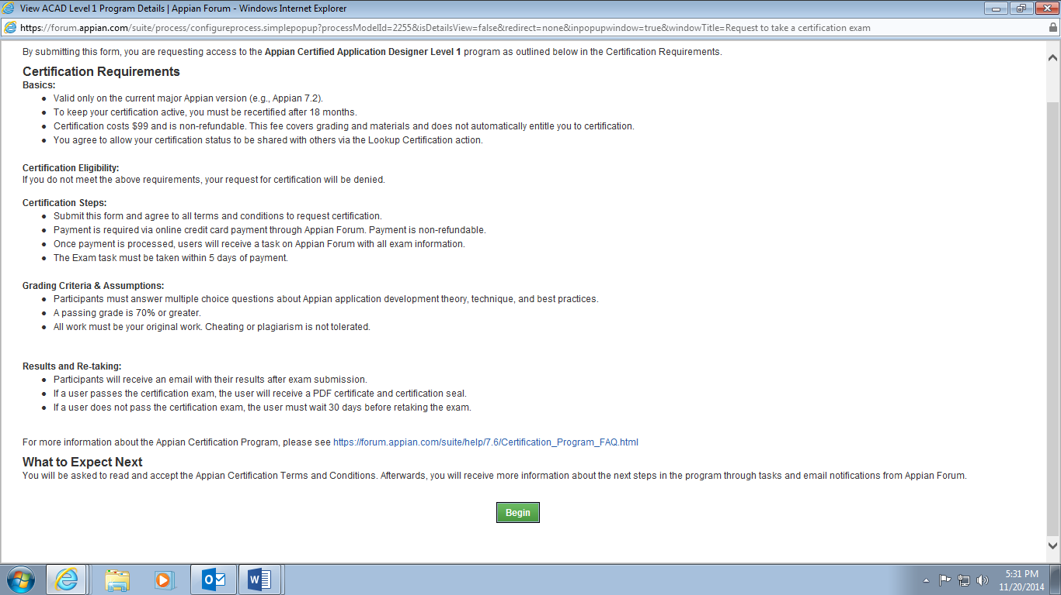

Clicked Begin
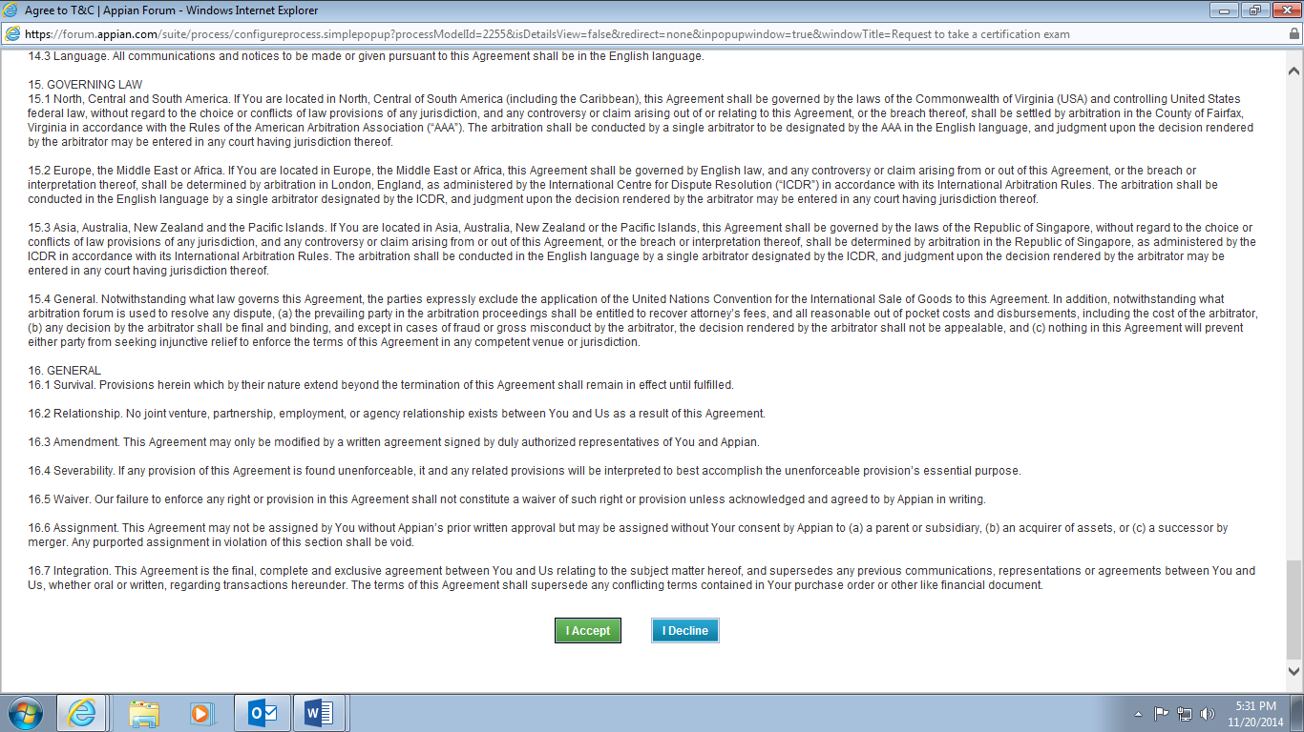
Clicked I Agree

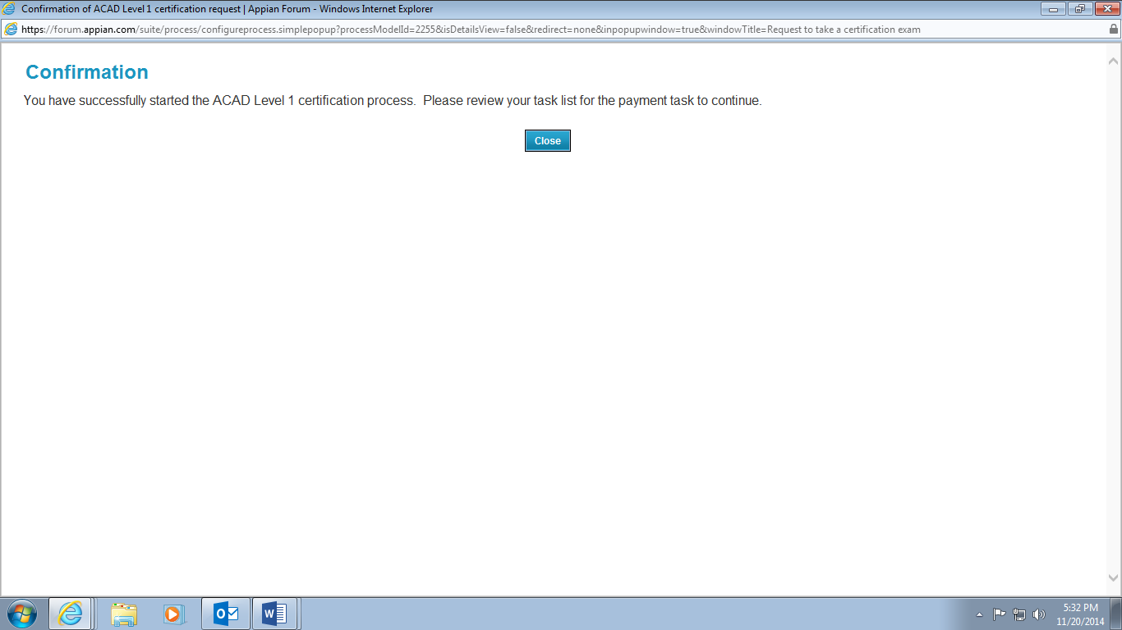

In TASK Start ACAD Level 1 Exam came and I clicked. I got 2 options Take Exam later and Begin Exam now. Then I chose Begin Exam Now. Now screen vanished and when I checked in Task no task was der regarding Certification. When again repeated above process again I got below task asAccess to ACAD L1 Exam Declined .

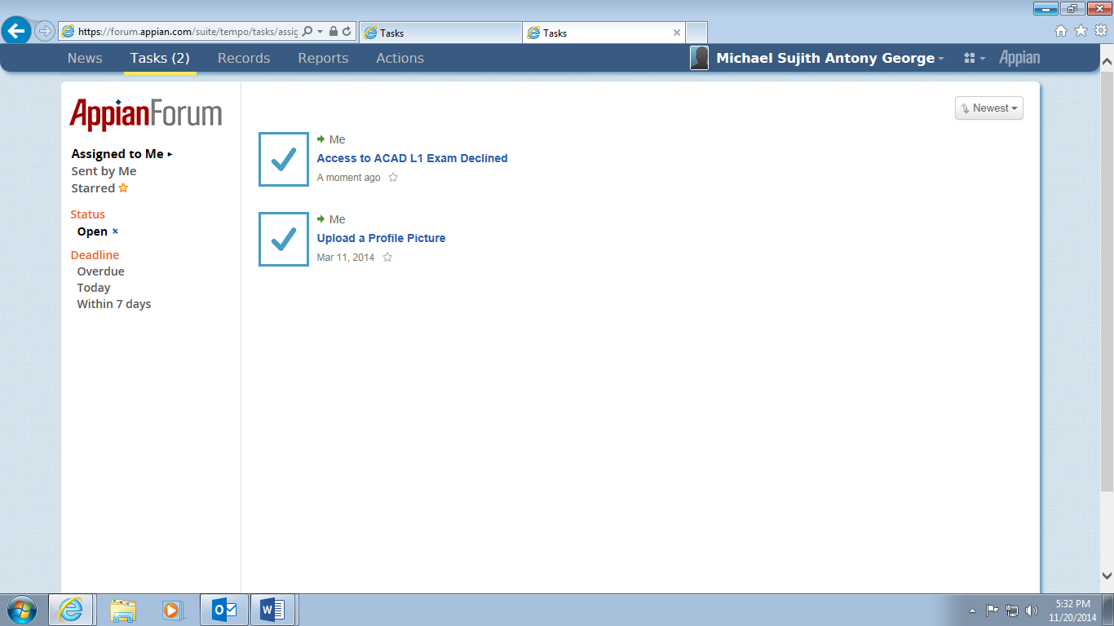

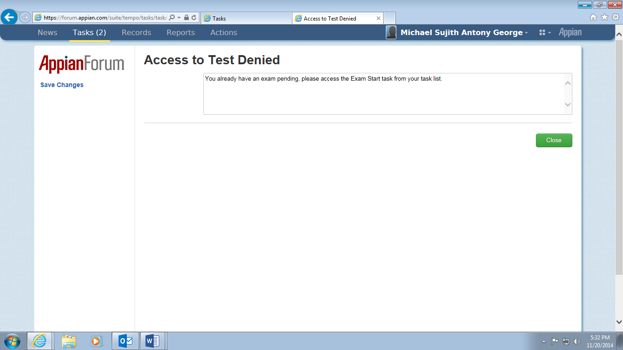
After Clicking close

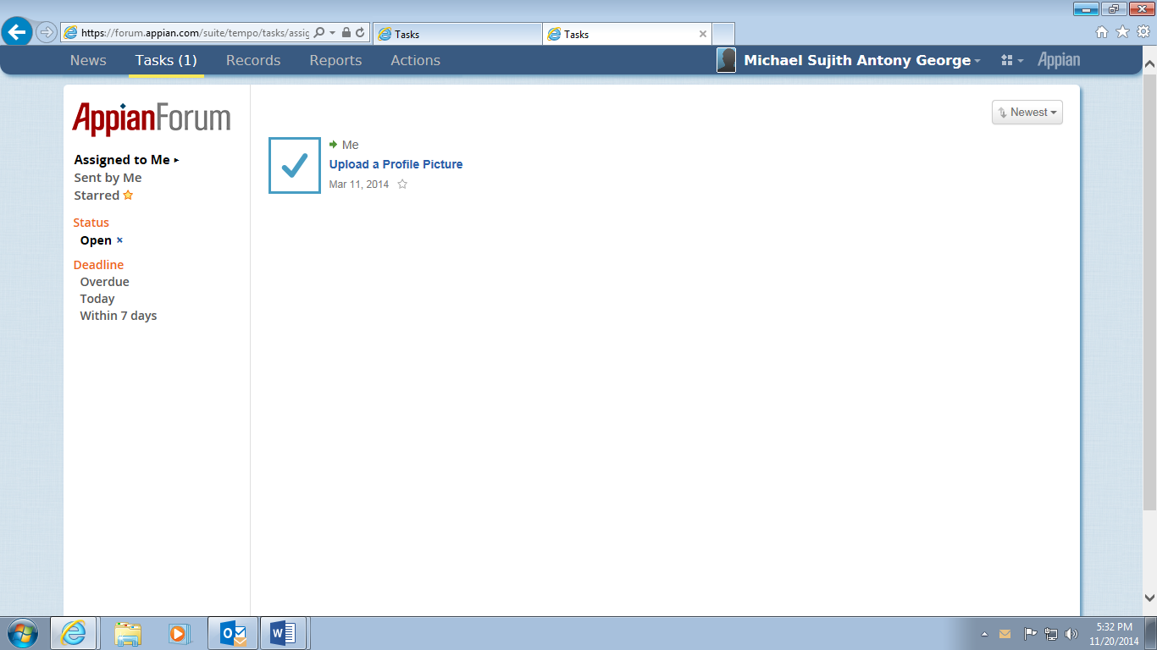

Even I tried accessing the lost task from my mail but still its was showing Task already submitted.

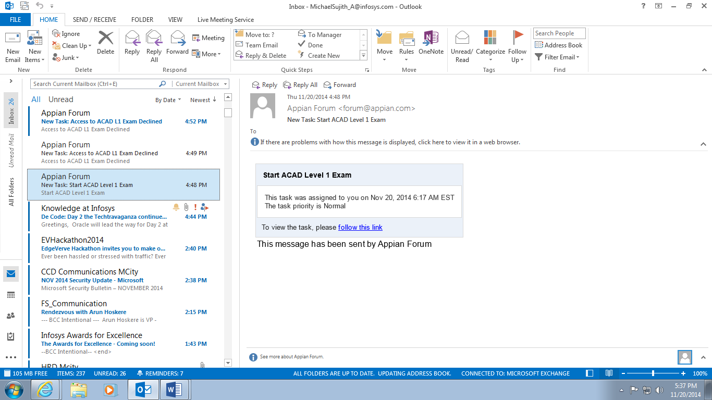
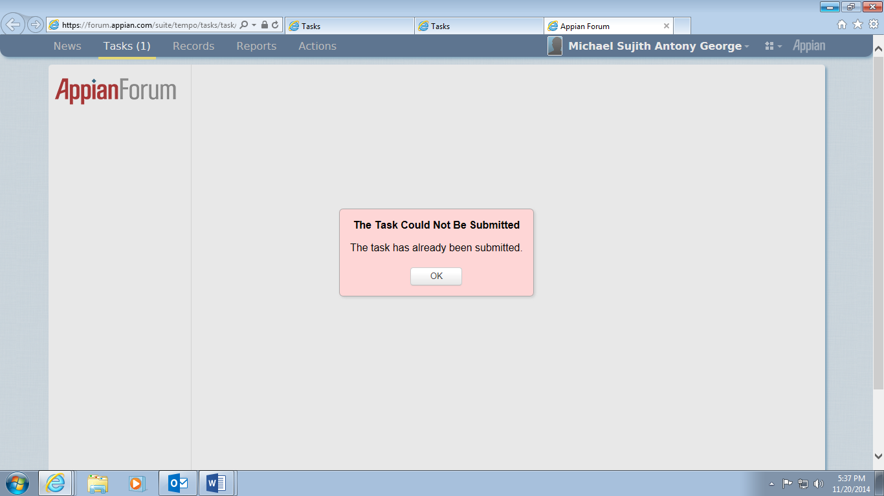

This is important I am not able to take APPIAN ACAD L1 so please help.

